

**CSE302: Database Systems (Section 2)**

**[SUMMER 2022]**

**Project Report**

**Group8**

Project/Application Title

**Capstone Database**

Project URL/Link

<https://apex.oracle.com/pls/apex/r/cse_302_summer/capstone-database>

**Submitted by:**

|  |  |  |
| --- | --- | --- |
| **Student ID** | **Student Name** | **Contribution Percentage** |
| **2019-1-60-007** | **Humayun Rashid Rahat** | **33.33%** |
| **2019-1-60-013** | **Md. Abir Hasan Khan** | **33.33%** |
| **2019-1-60-025** | **Hasibul Hasem Shanto** | **33.33%** |
|  |  |  |
|  |  |  |

# Final version of the E-R Model of the Project

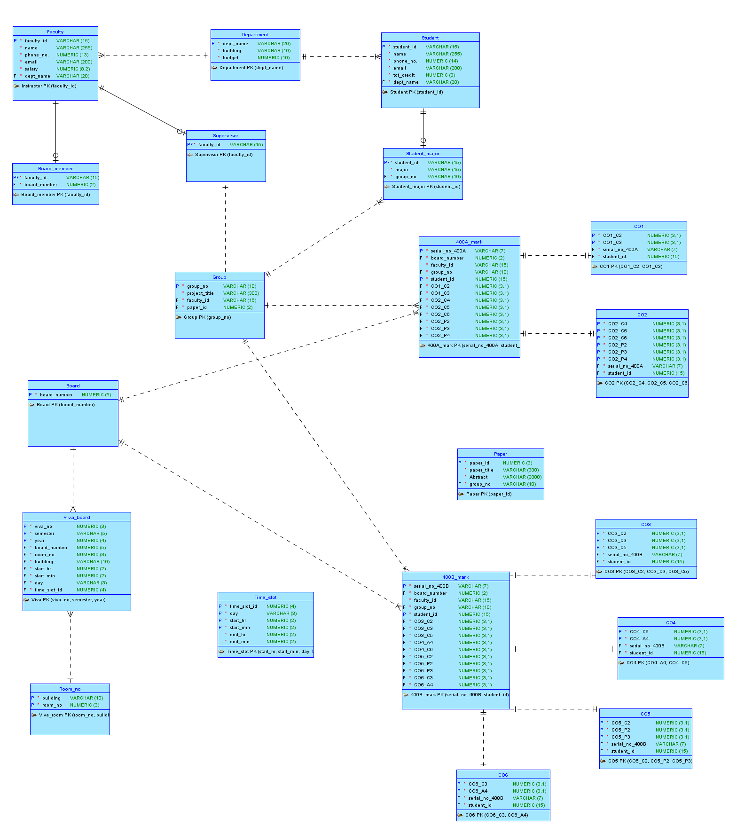

# Final Version of the Relational Data Model of the Project

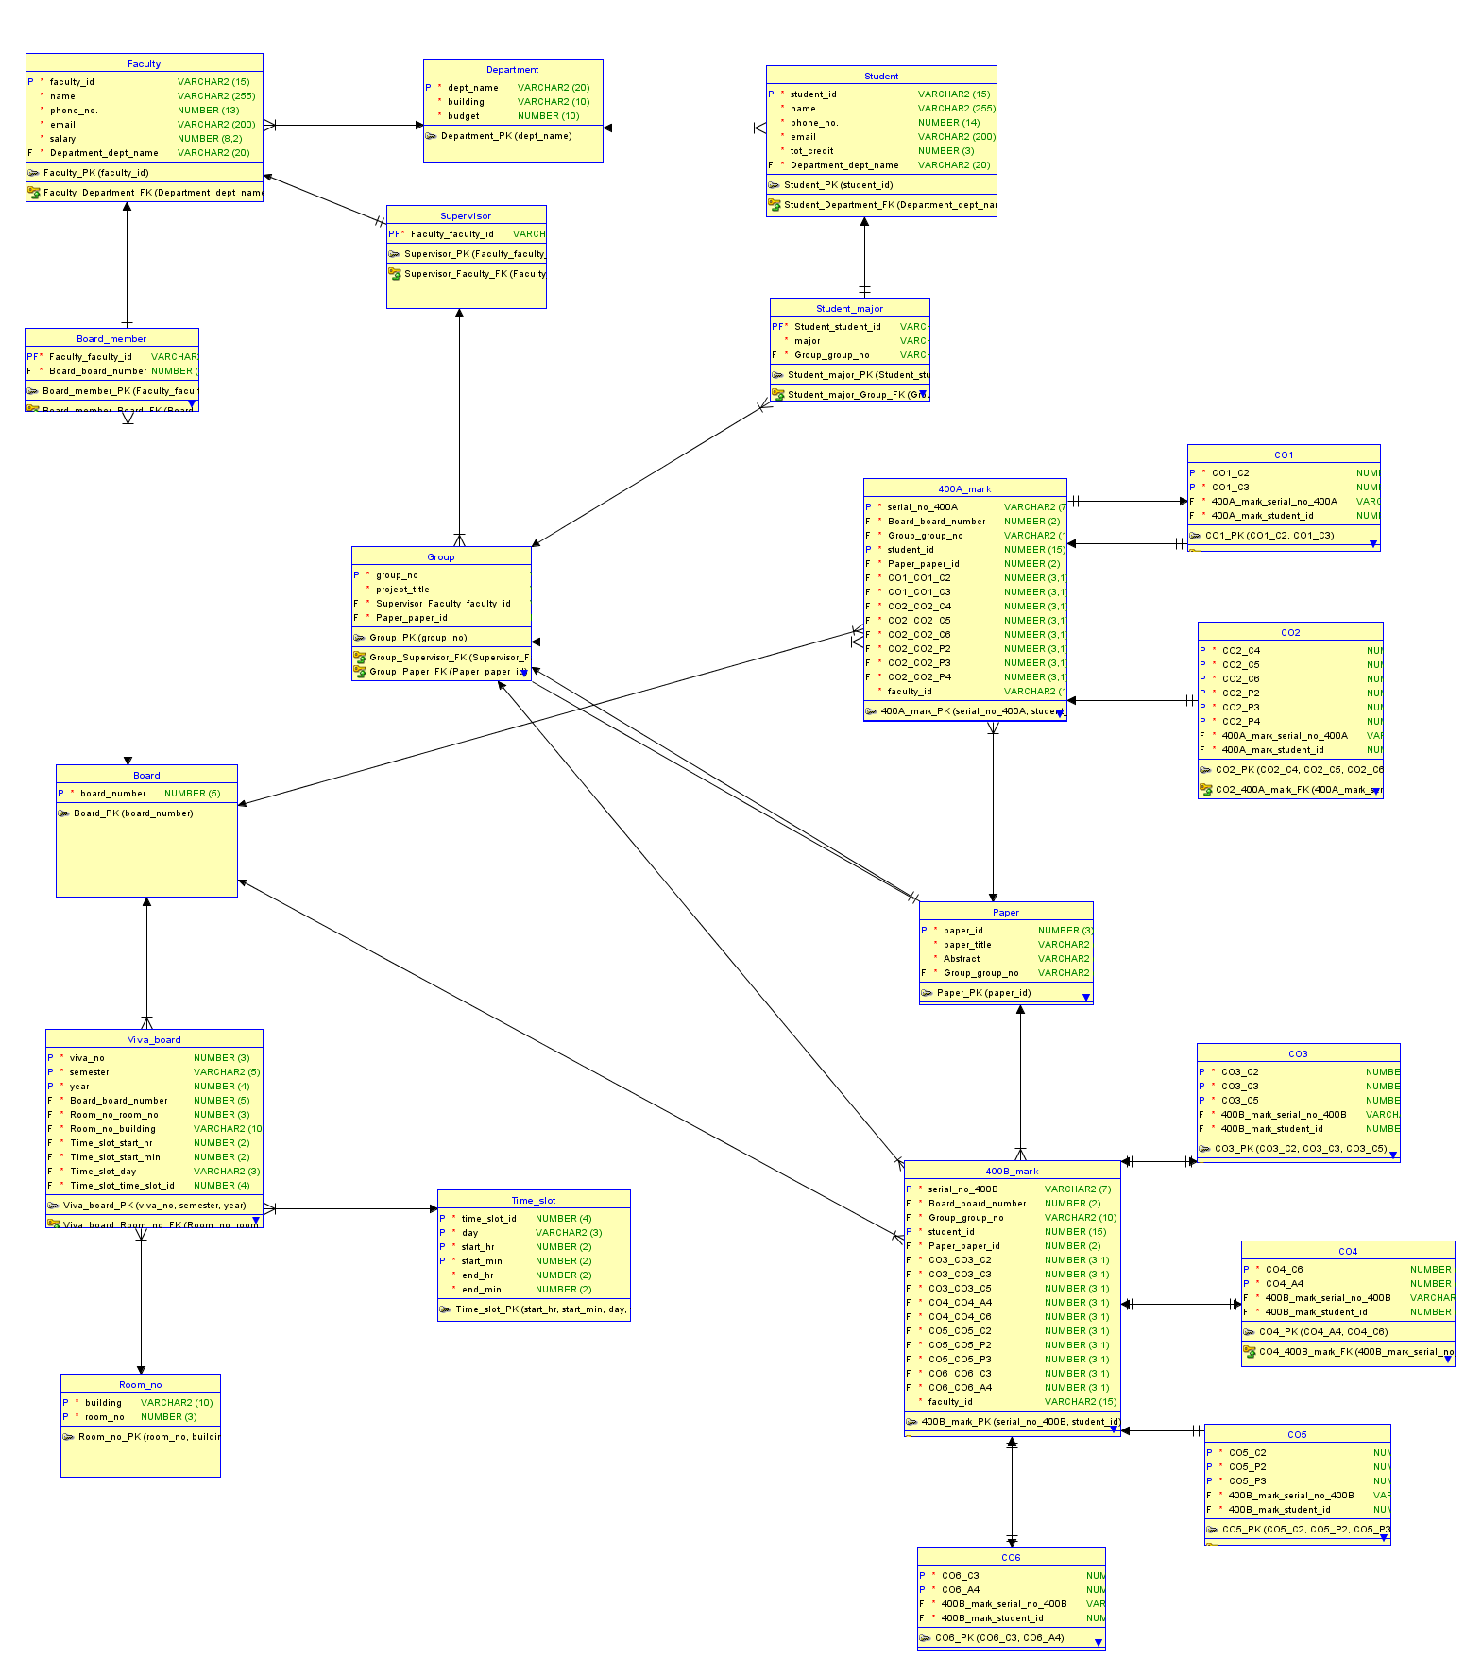

# Implementation Checklist

|  |  |
| --- | --- |
| Description | Remarks |
| Project ID | Application 152760 |
| Workspace Name | cse_302_summer |
| Workspace Email | blackshark622@gmail.com |
| Workspace Password | retro12345 |
|  |  |
| Authentication Type | Application Express/Custom (keep the relevant one) |
| Username and Password to Login |  |
| admin | admin123 |
| faculty | faculty123 |
| student | student123 |
|  |  |
| Uploaded and Displayed Images in Reports | yes |
| Implemented Page-wise Authorization | no |
|  |  |
| Number of Reports with Forms |  |
| Number of Master-detail Forms |  |
| Number of Reports based on Queries, Aggregate Queries | 2 |
| Number of Parameterized Reports |  |
| Number of Graphs/Charts | 1 |
|  |  |
| Included any trigger/other feature which is not taught in class. If yes, please explain briefly. | 8 triggers |
| Write the most unique feature/functionality in your application or the page of your application that you are proud of. Explain briefly. | When we enter marks on 400A & 400B,  through triggers those marks distribute to other tables. |

# Reports with Forms

|  |  |  |
| --- | --- | --- |
| Report Page Number and Name | Form Page Number and Name | Table |
| department report | department | Department |
| Student report | student | Student |
| Student image upload report | Student image upload | Student Image |
| Faculty report | Faculty | Faculty |
| Faculty image upload report | Faculty image upload | Faculty Image |
| Board report | Board | Board |
| Supervisor report | supervisor | supervisor |
| Time_slot report | Time slot | Time slot |
| Viva_report | Viva_board | Viva_board |
| Student Major report | Student major | Student major |
| Board member report | Board member | Board_member |
| Group board report | Group_board | Group_board |
| Group NameV1 report | Group NameV1 | Group NameV1 |
| Student Group report | Student Group | Group Student |
| 400A_mark report | 400A_mark | (400A mark by Faculty, 400A mark) |
| 400B_mark report | 400B_mark | (400B mark by Faculty, 400B mark) |
| Rooms report | Room | Room_no |
|  |  |  |
|  |  |  |
|  |  |  |
|  |  |  |
|  |  |  |
|  |  |  |
|  |  |  |
|  |  |  |
|  |  |  |
|  |  |  |

**Screenshots of Forms & Reports:**

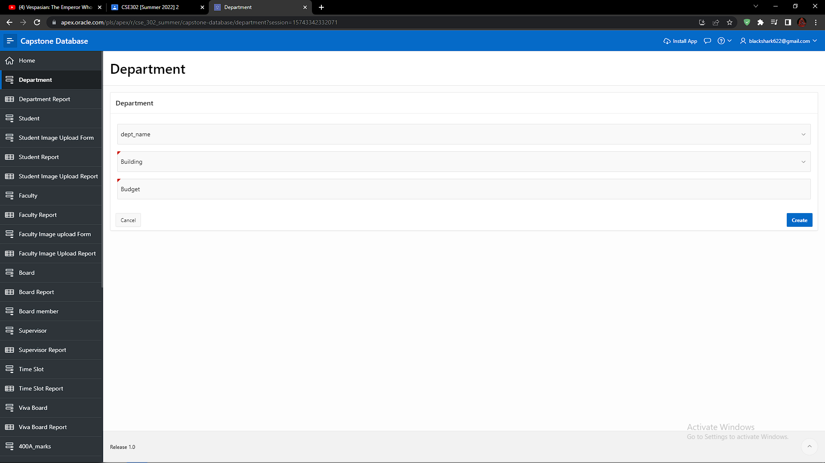

Fig: 4.1

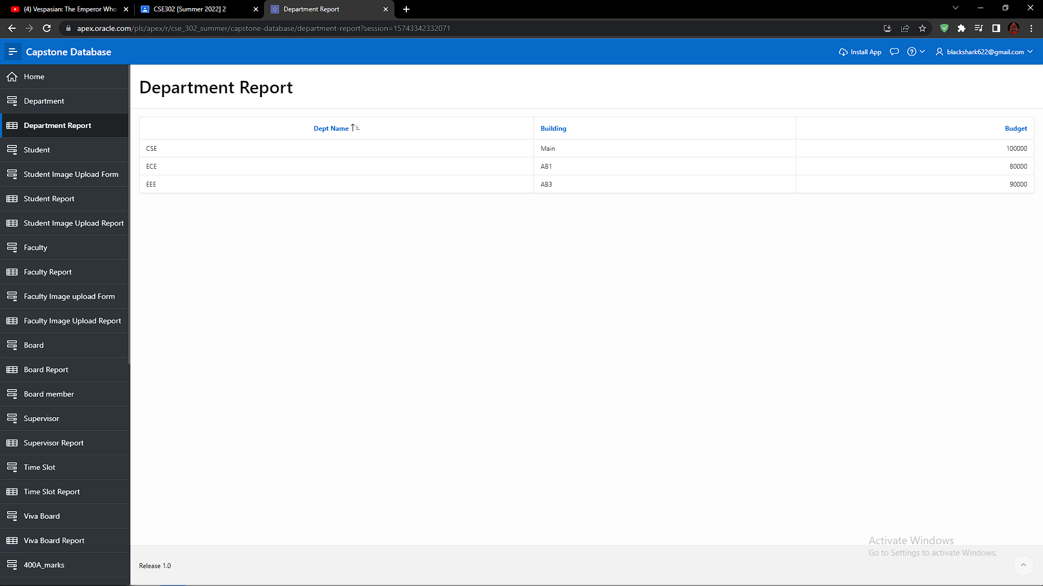

Fig-4.2

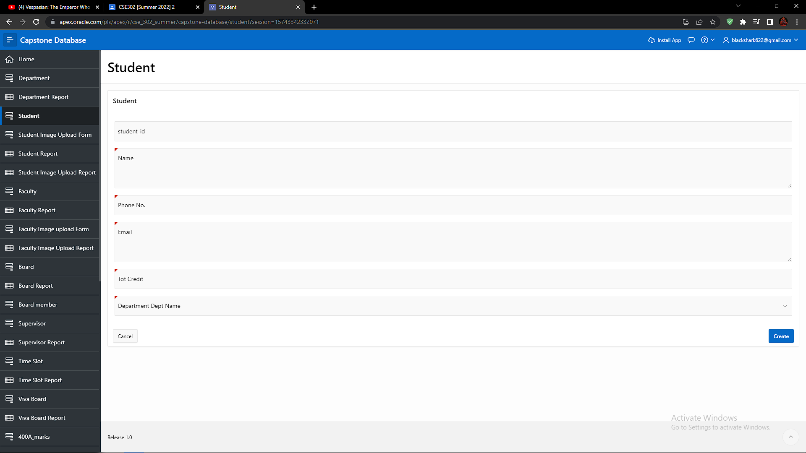

Fig-4.3

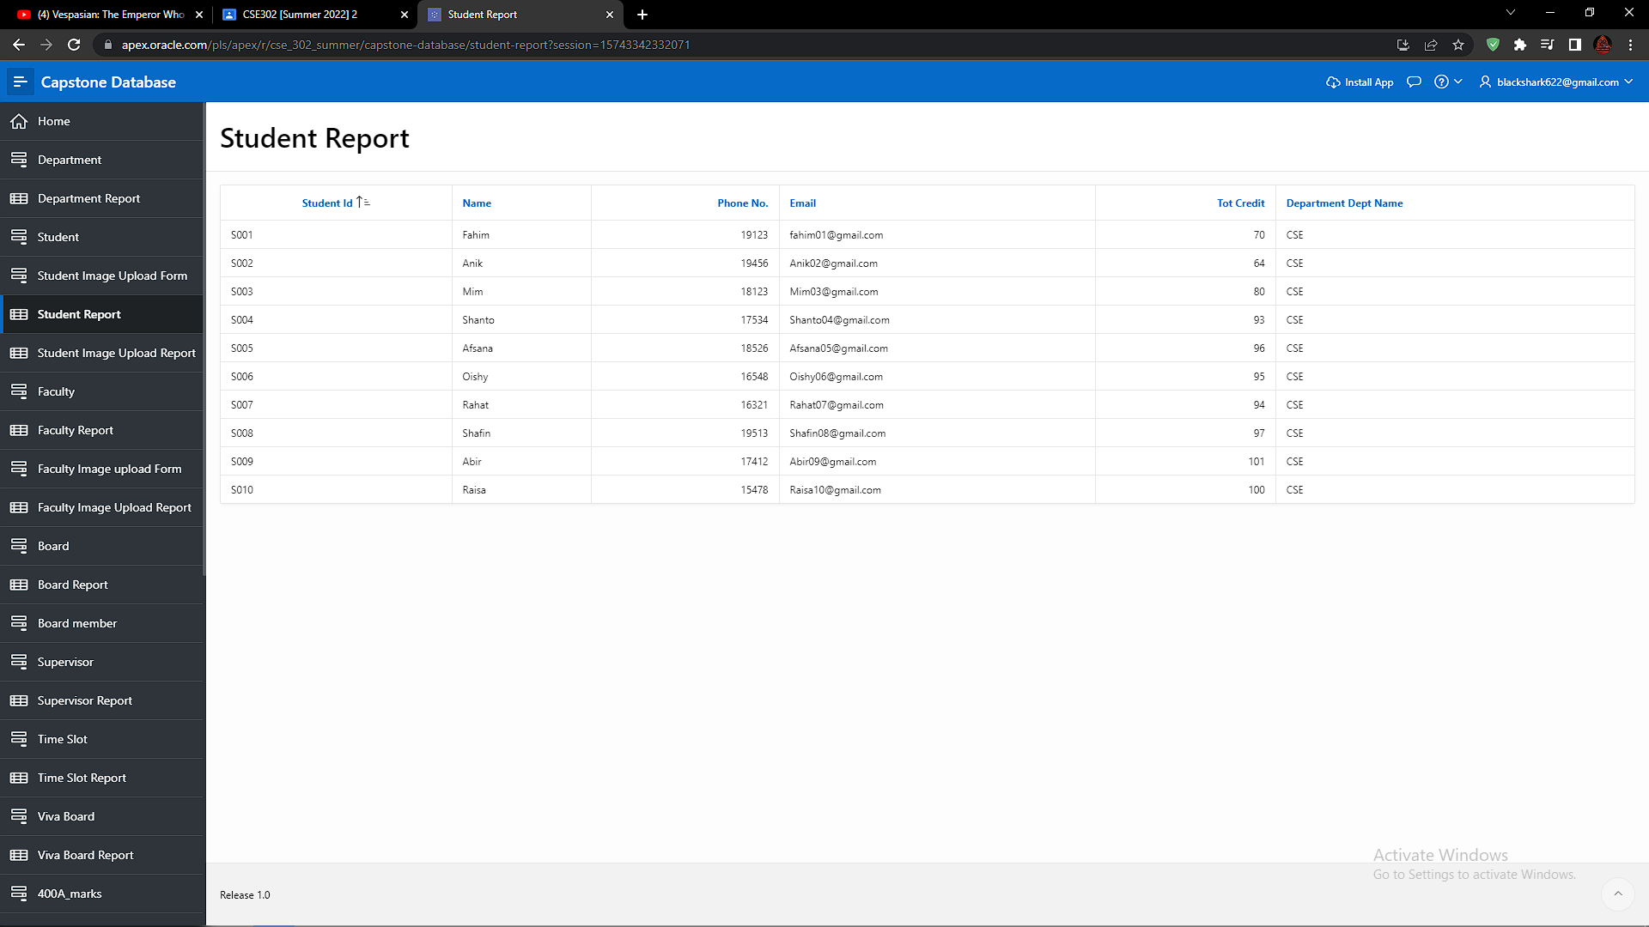

Fig-4.4

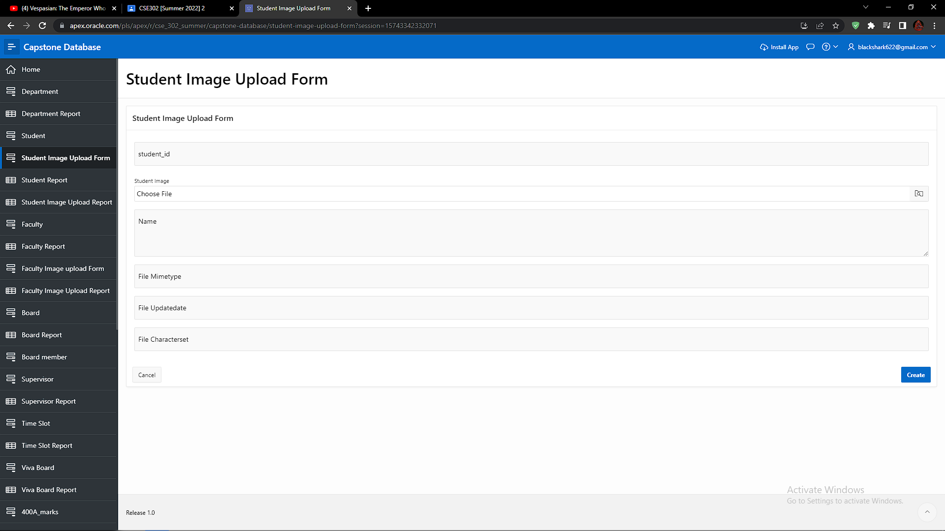

Fig-4.5

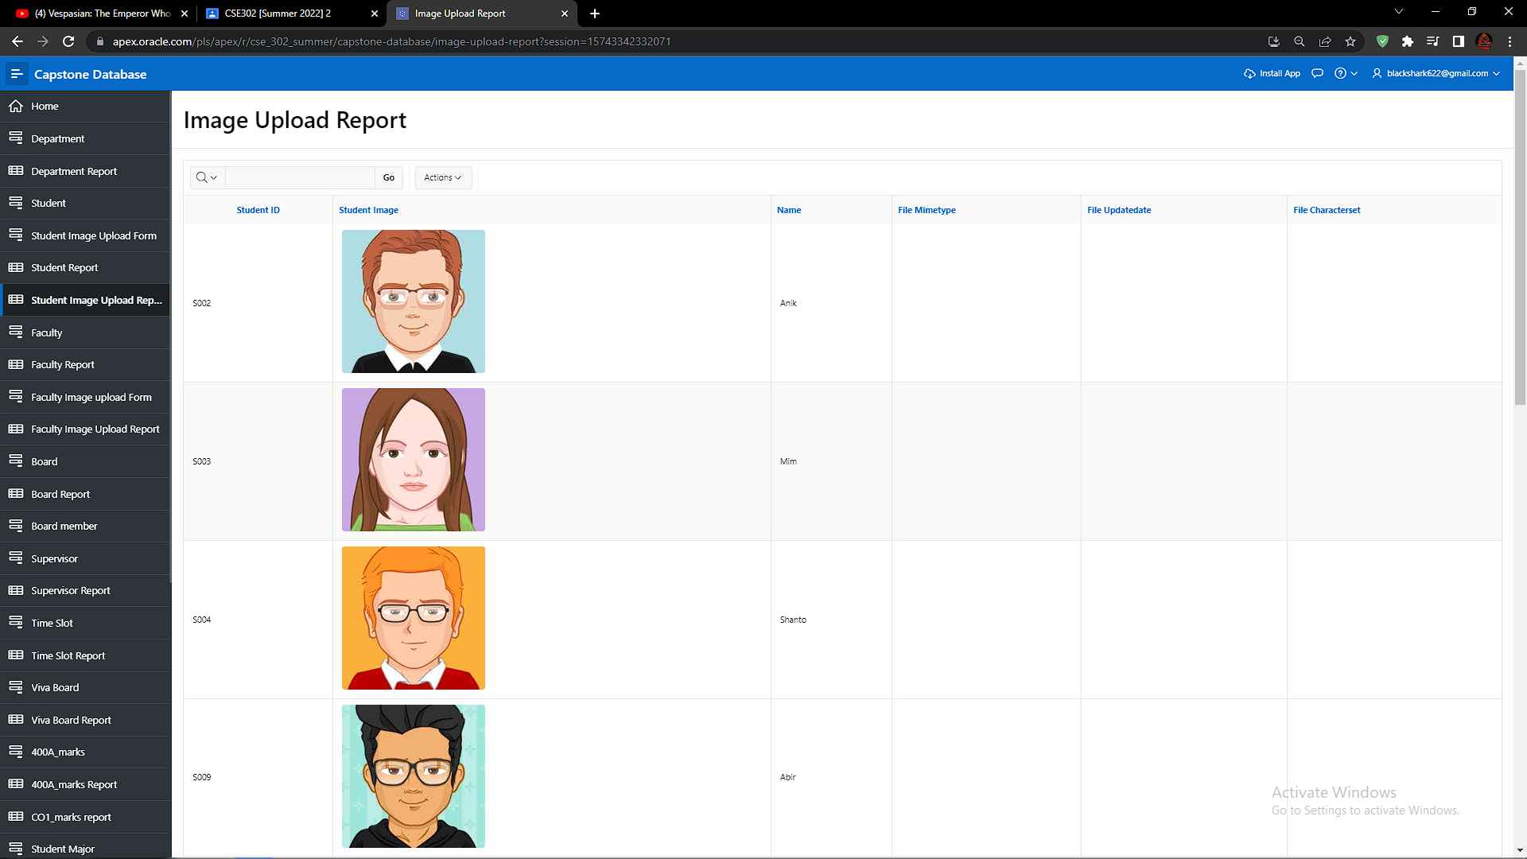

Fig-4.6

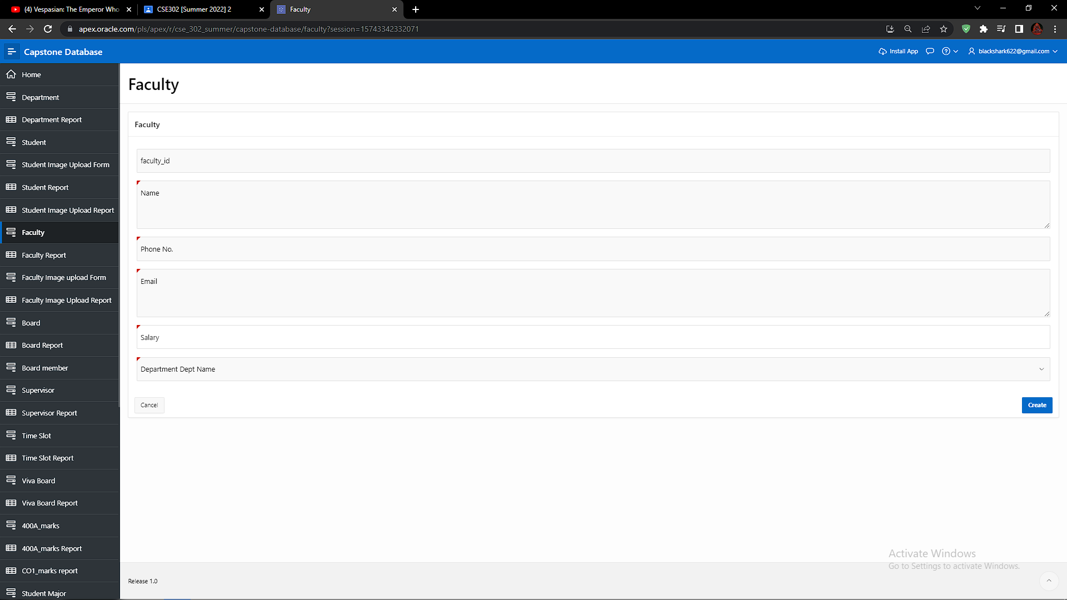

Fig-4.7

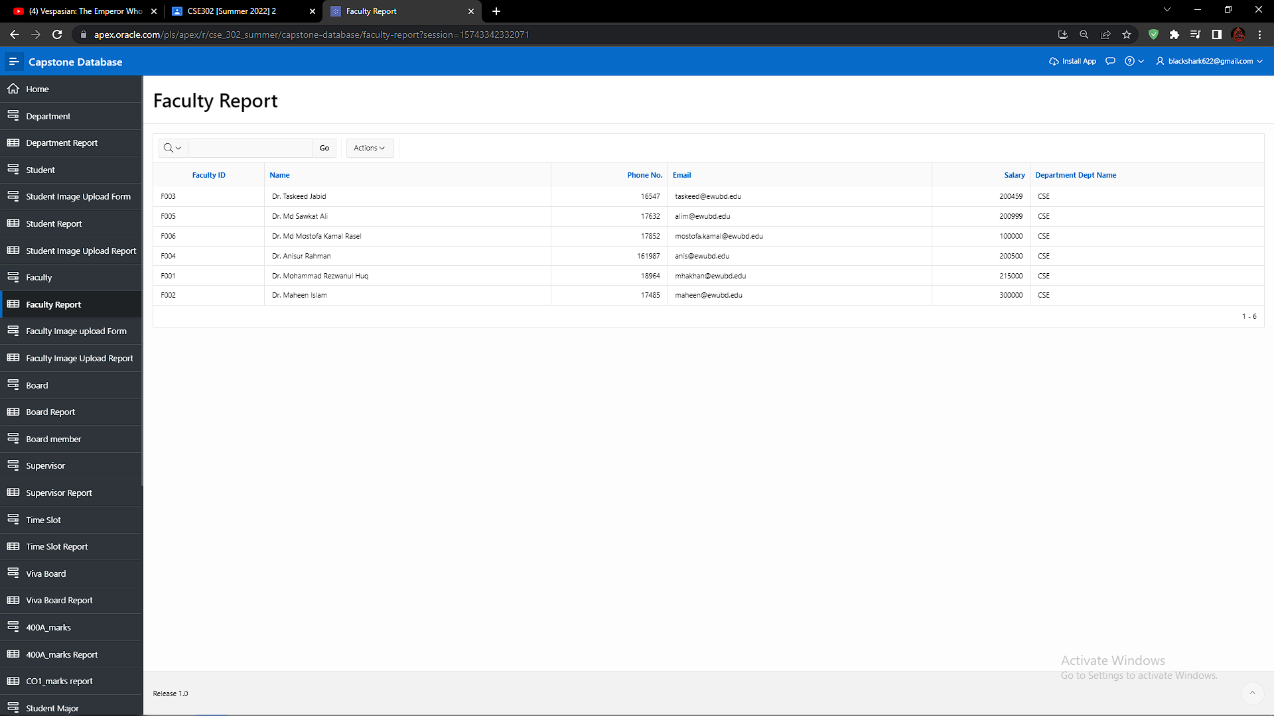

Fig-4.8

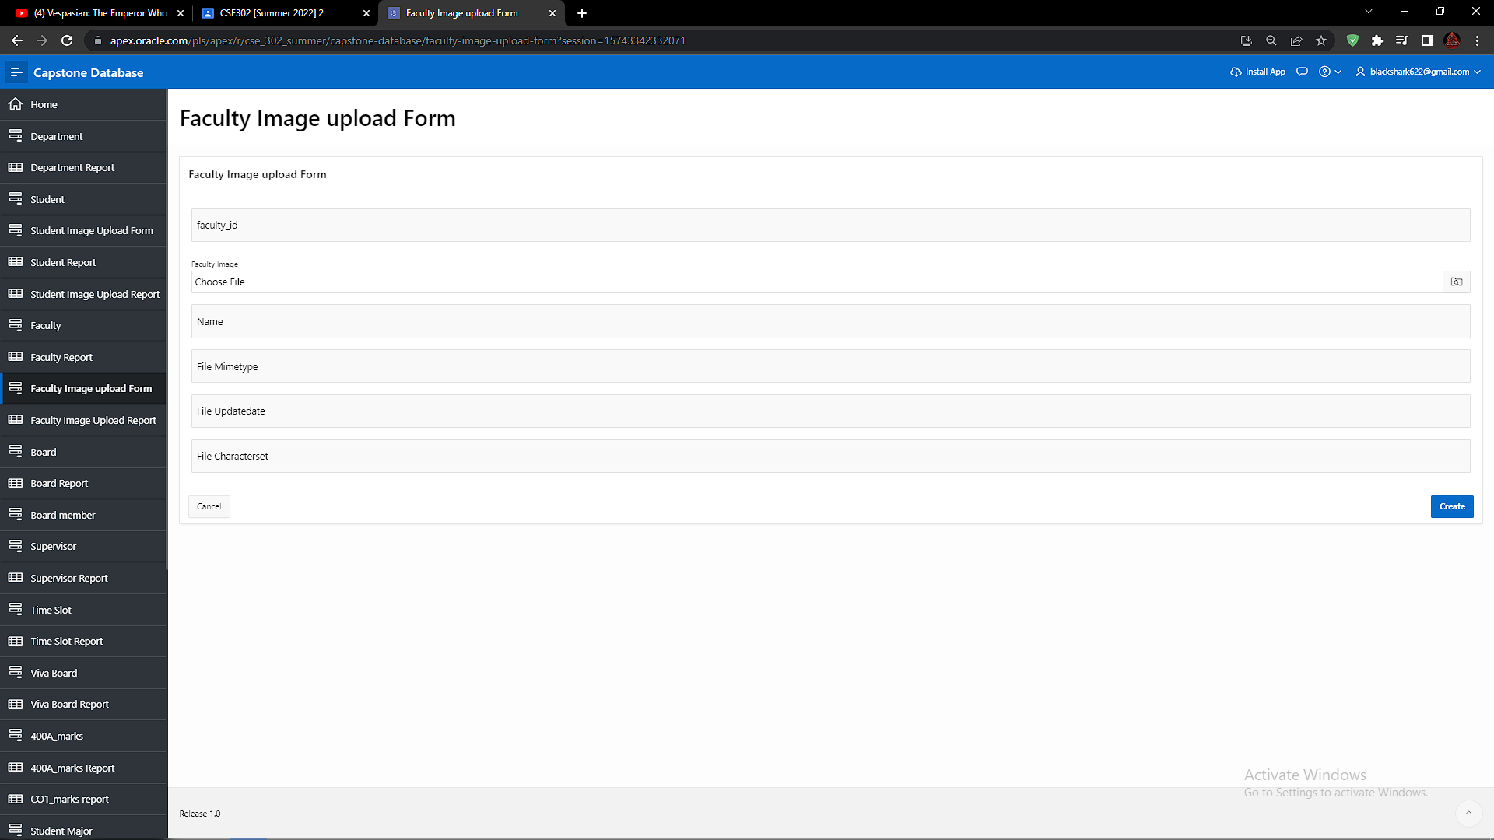

Fig-4.9

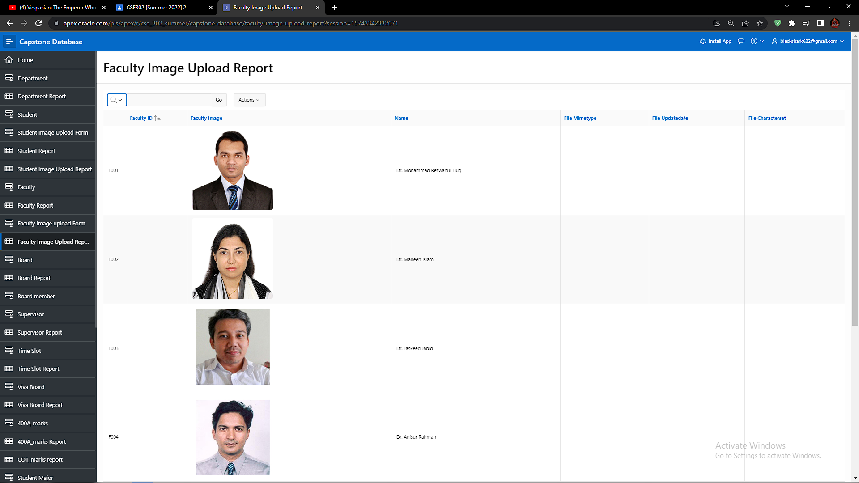

Fig-4.10

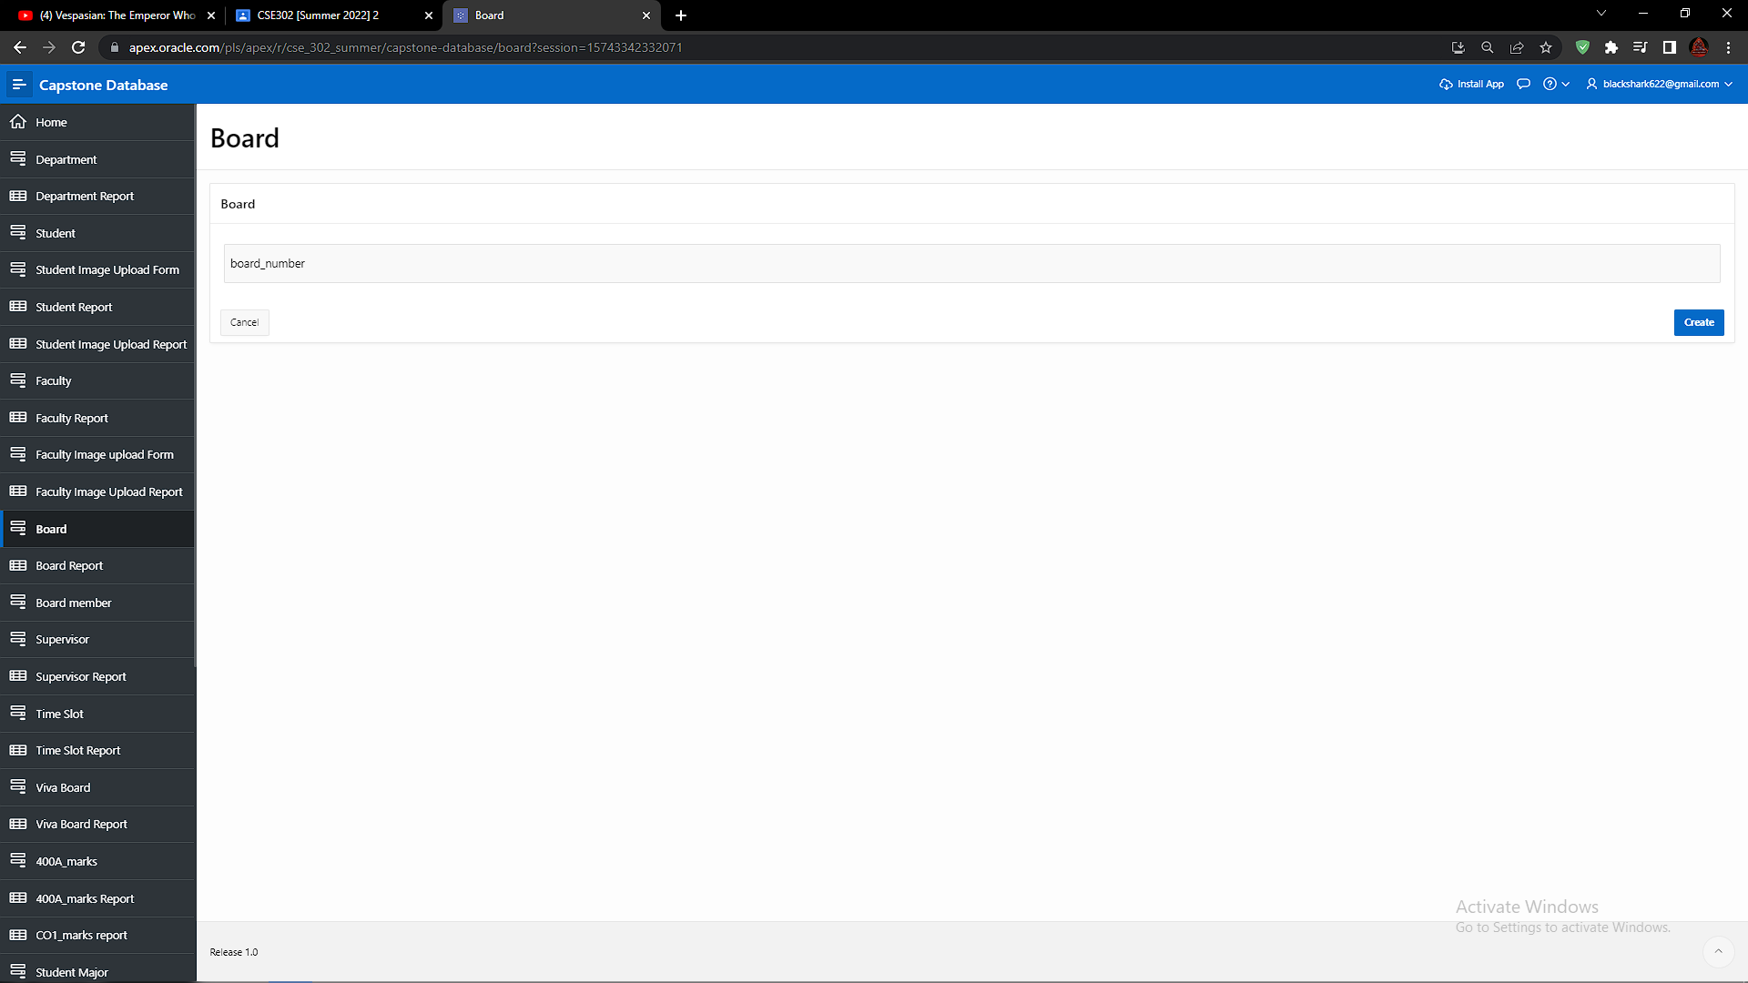

Fig-4.11

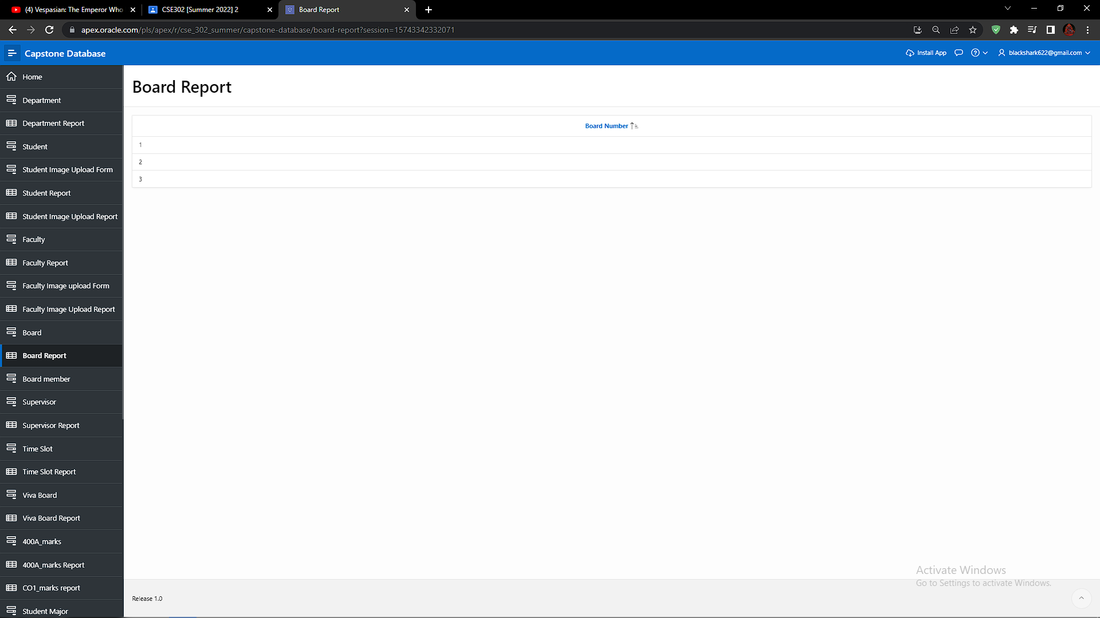

Fig-4.12

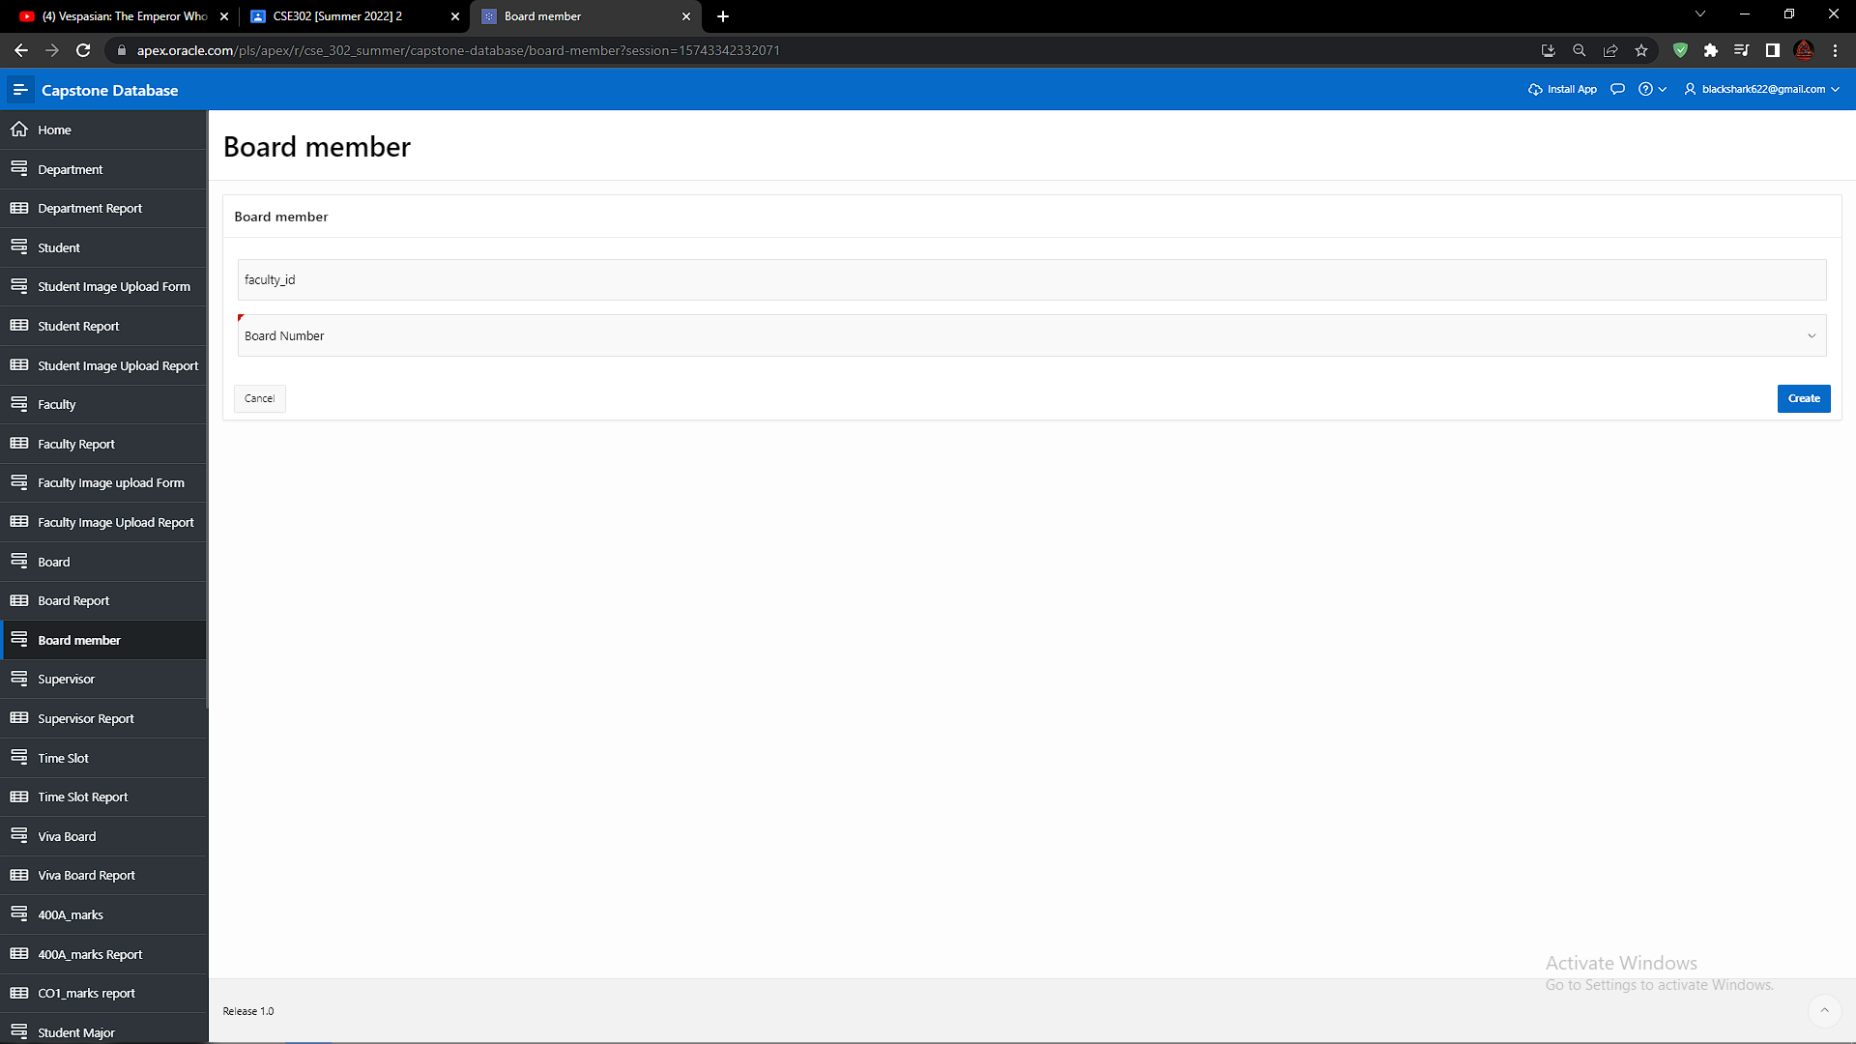

Fig-4.13

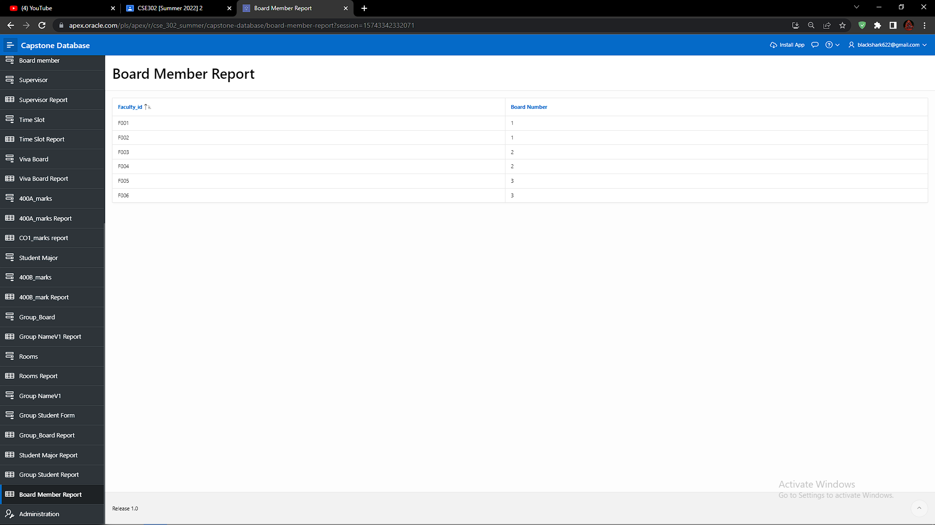

Fig-4.14

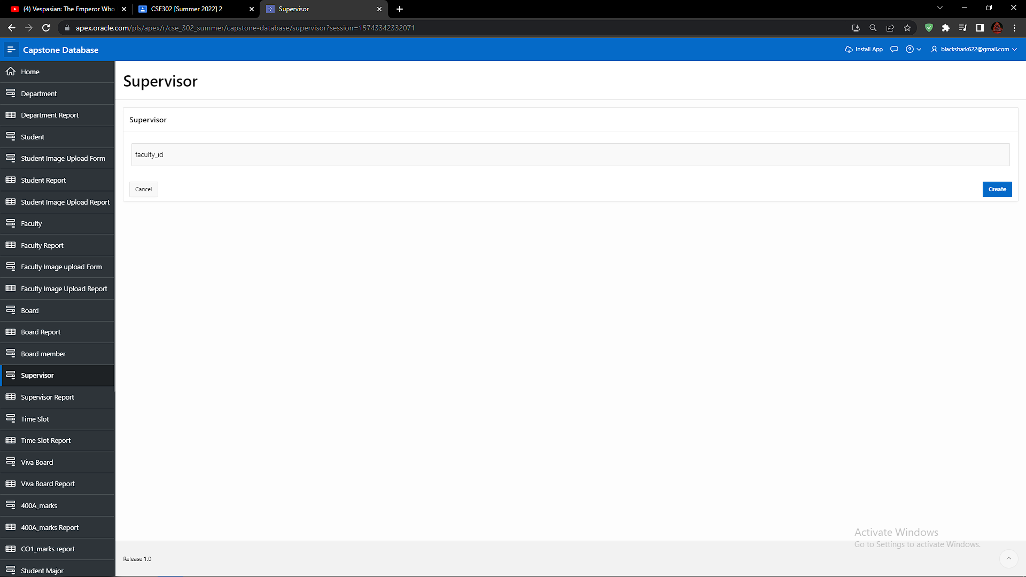

Fig-4.15

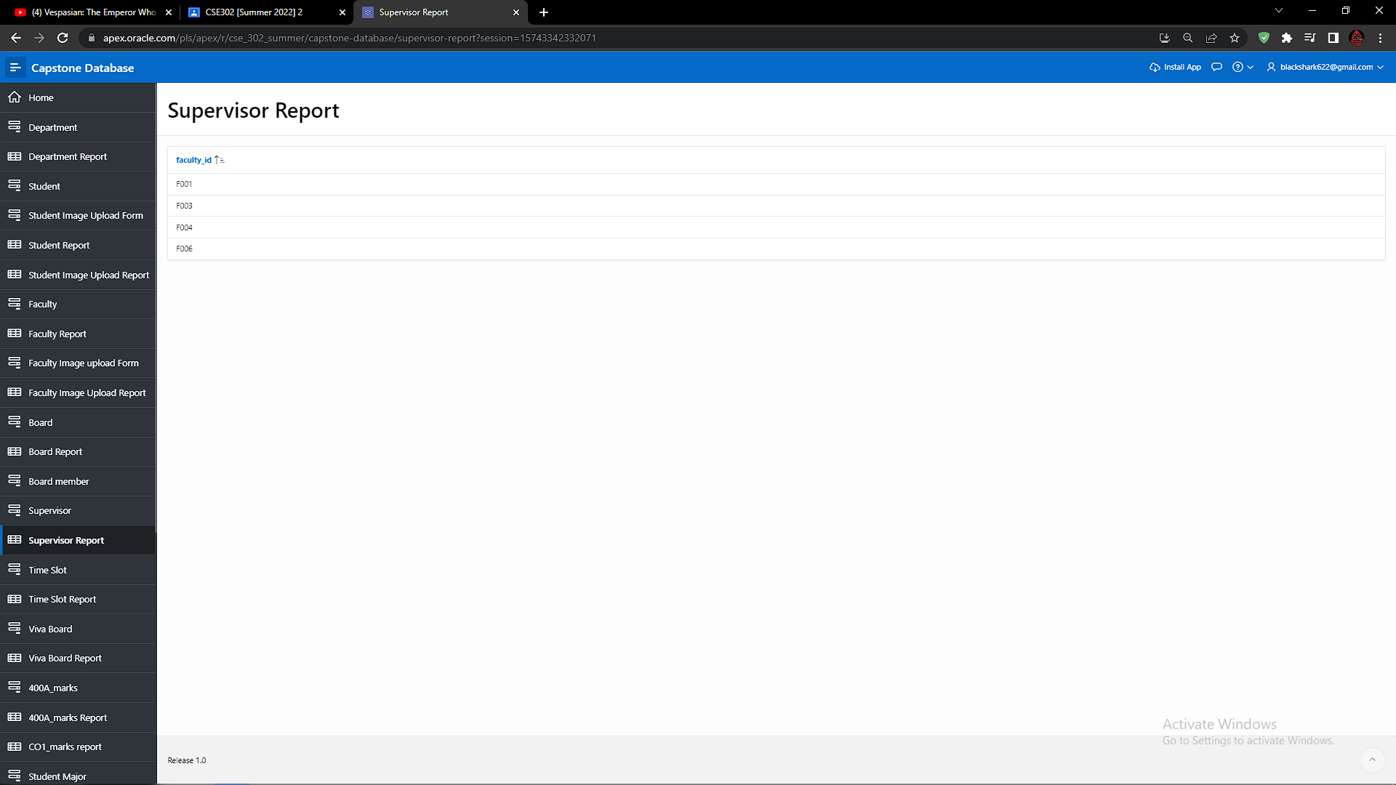

Fig-4.16

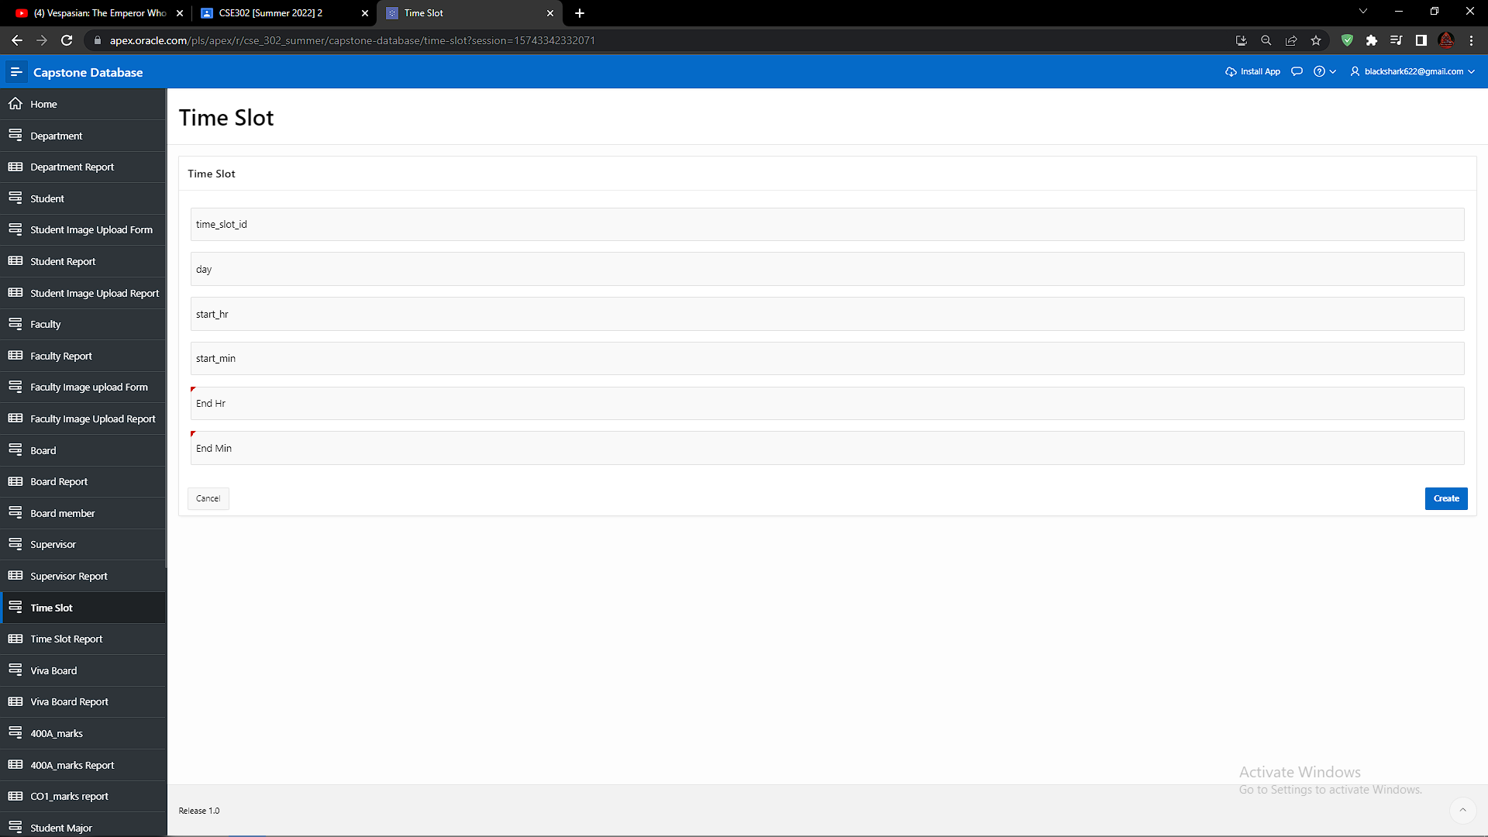

Fig-4.17

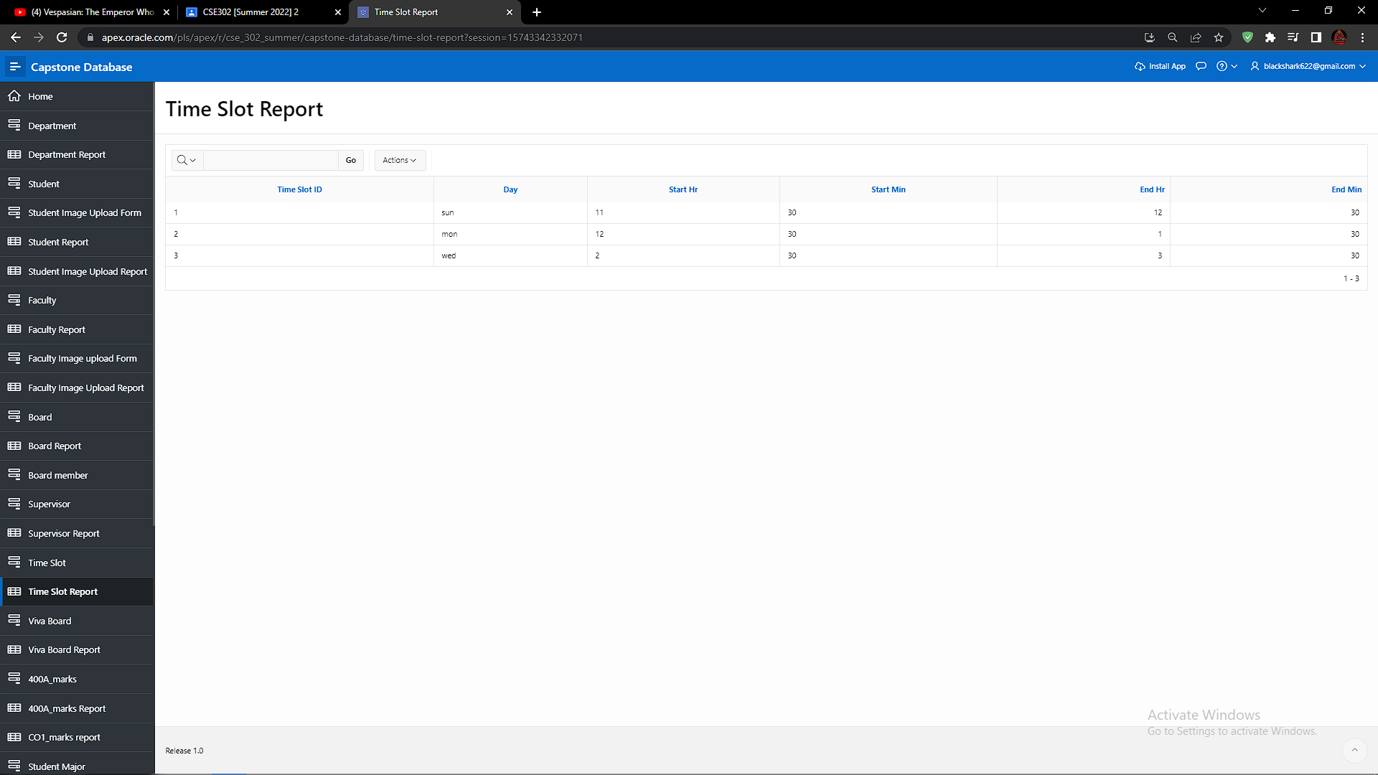

Fig-4.18

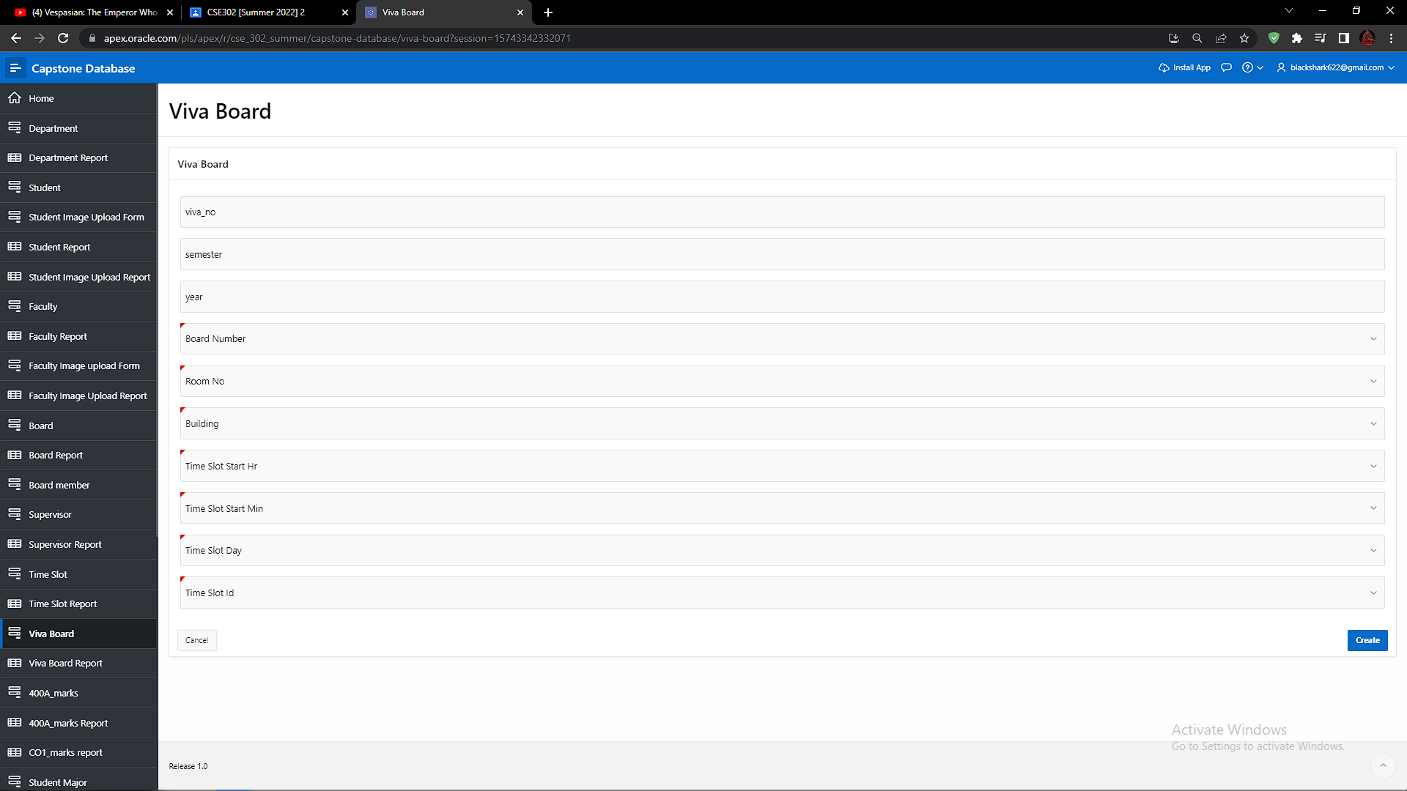

Fig-4.19

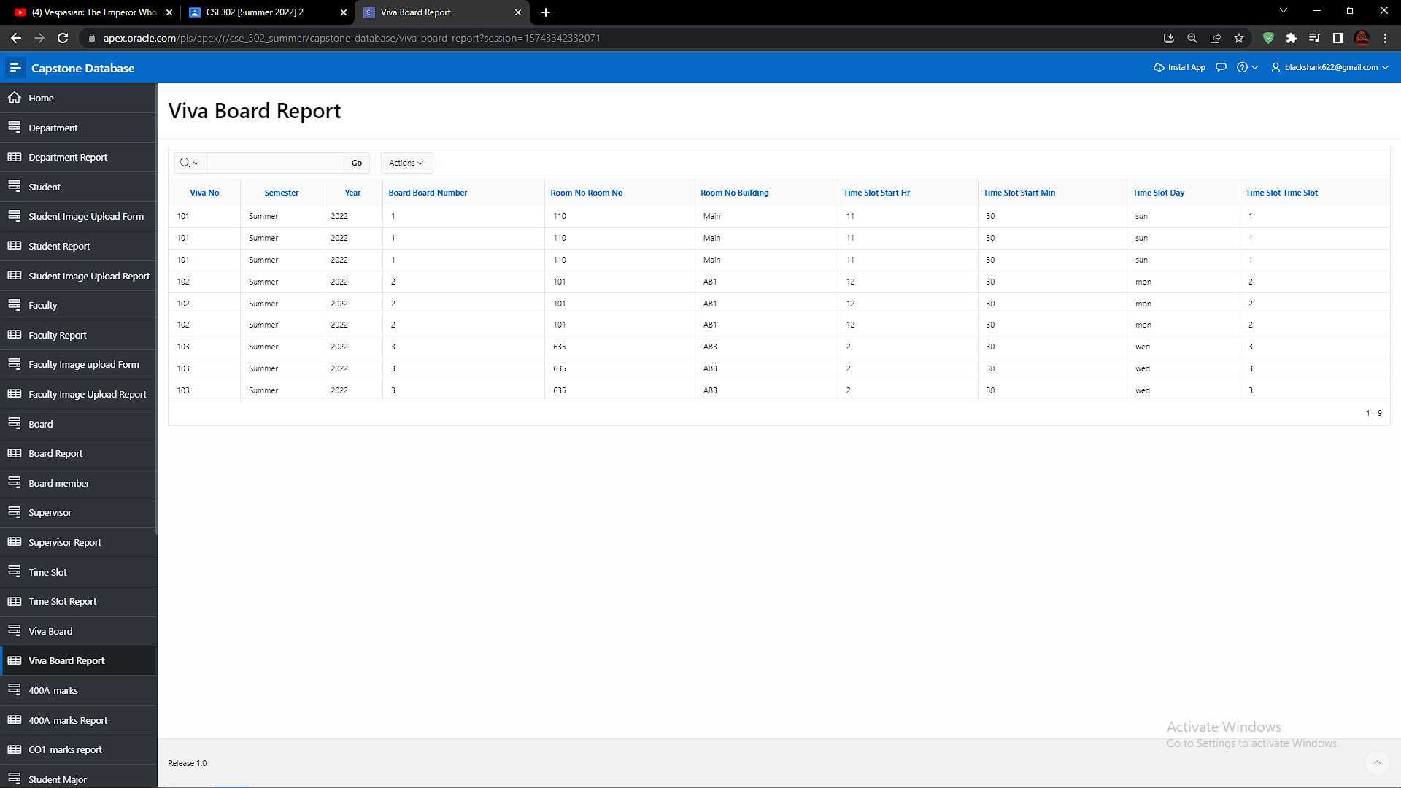

Fig-4.20

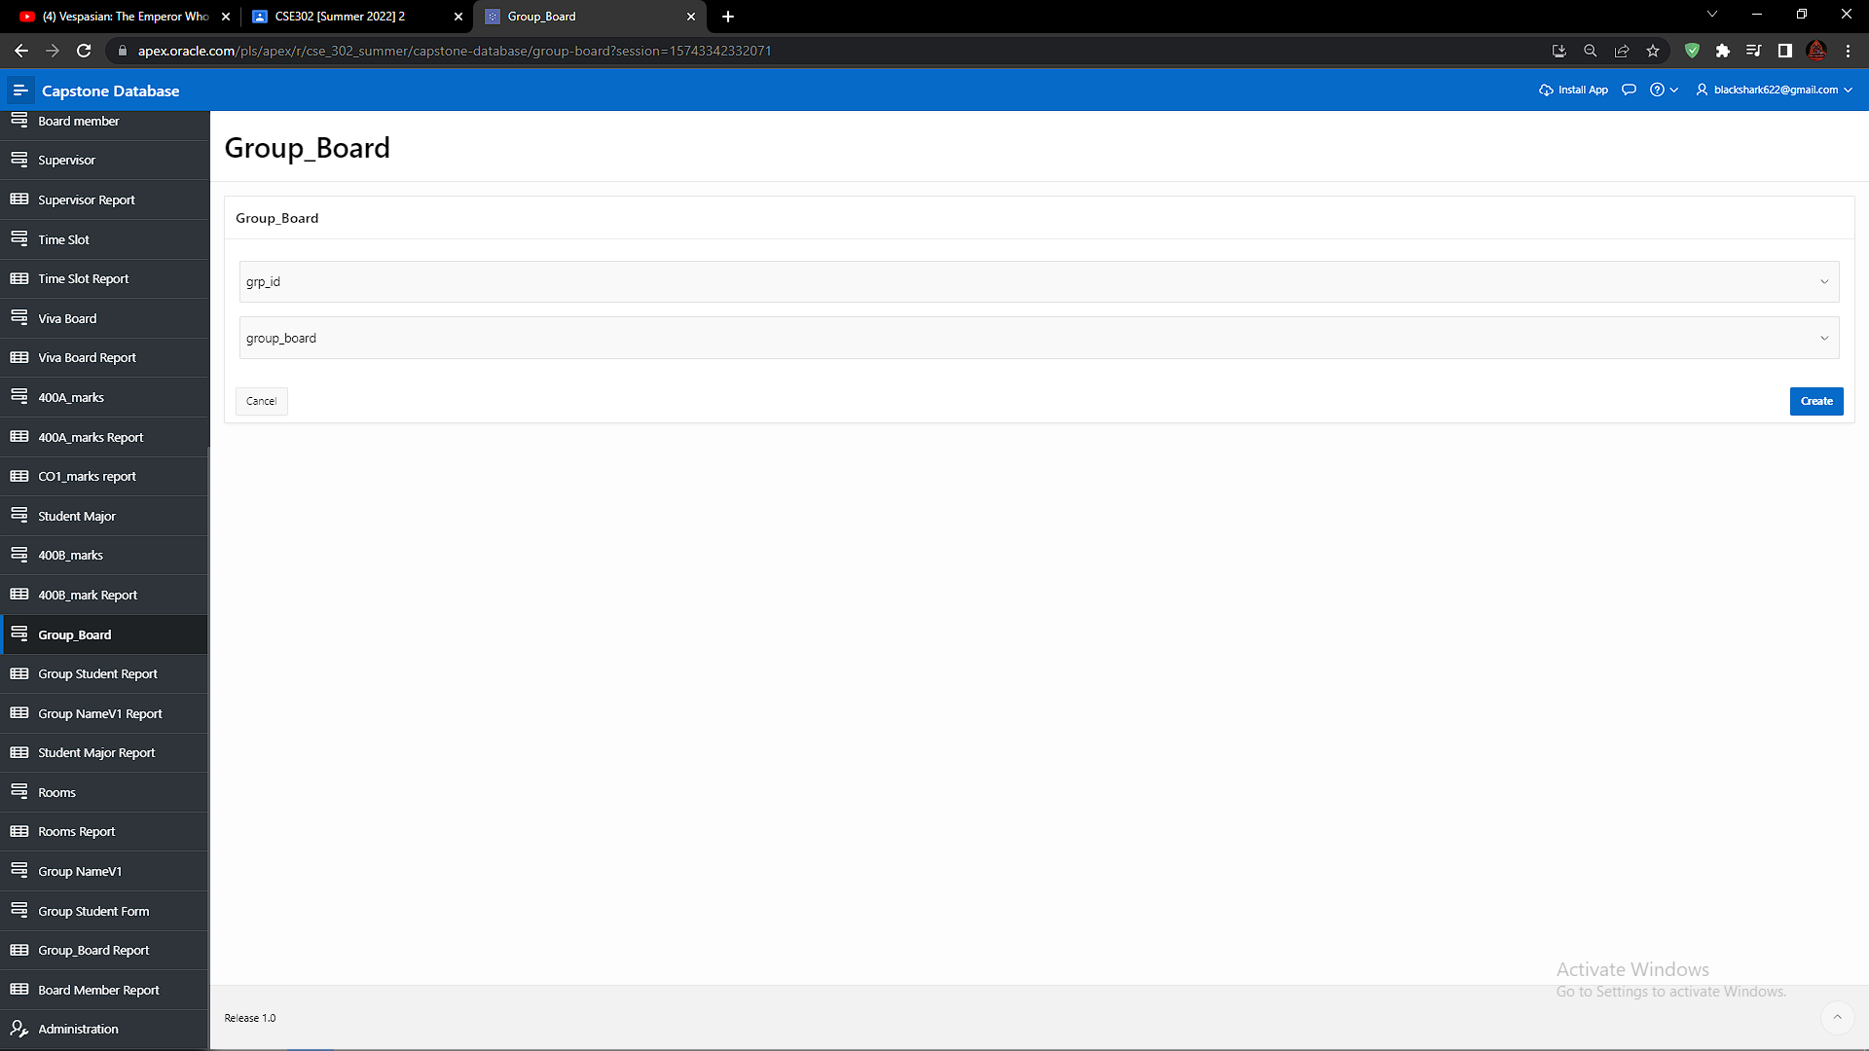

Fig-4.21

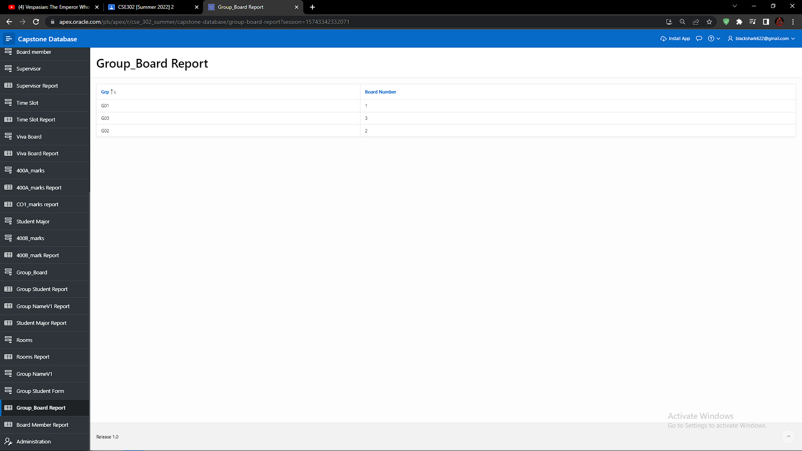

Fig-4.22

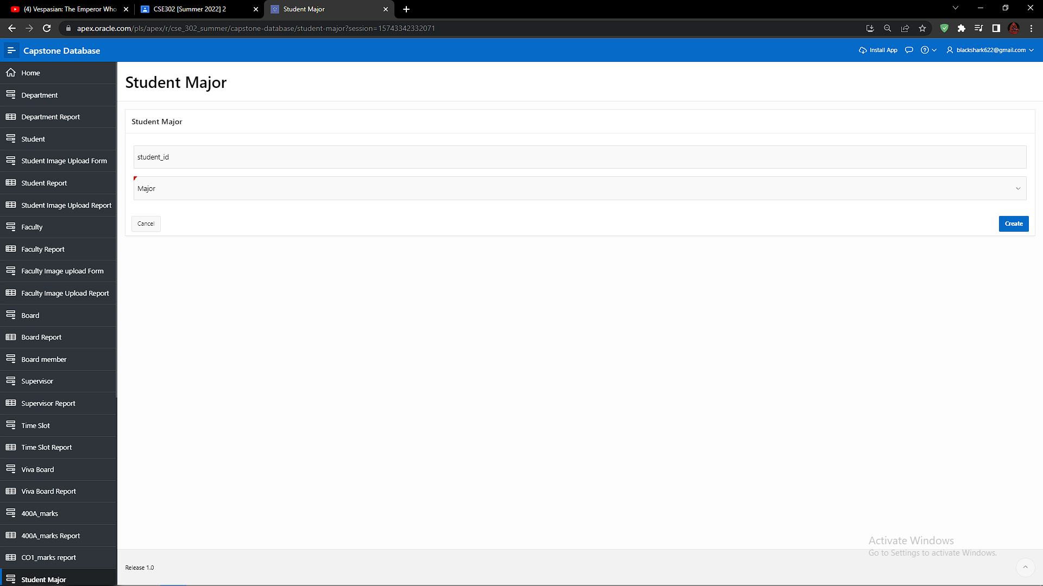

Fig-4.23

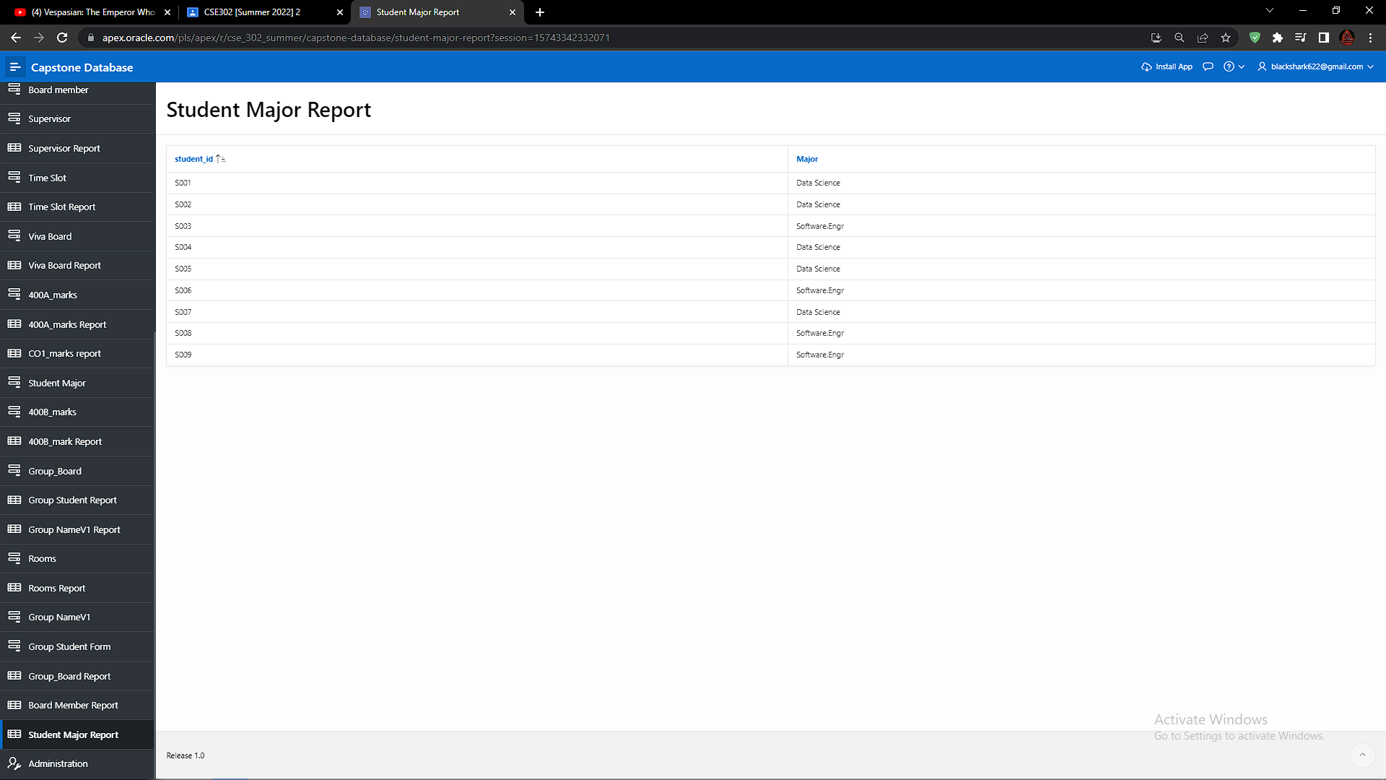

Fig-4.24

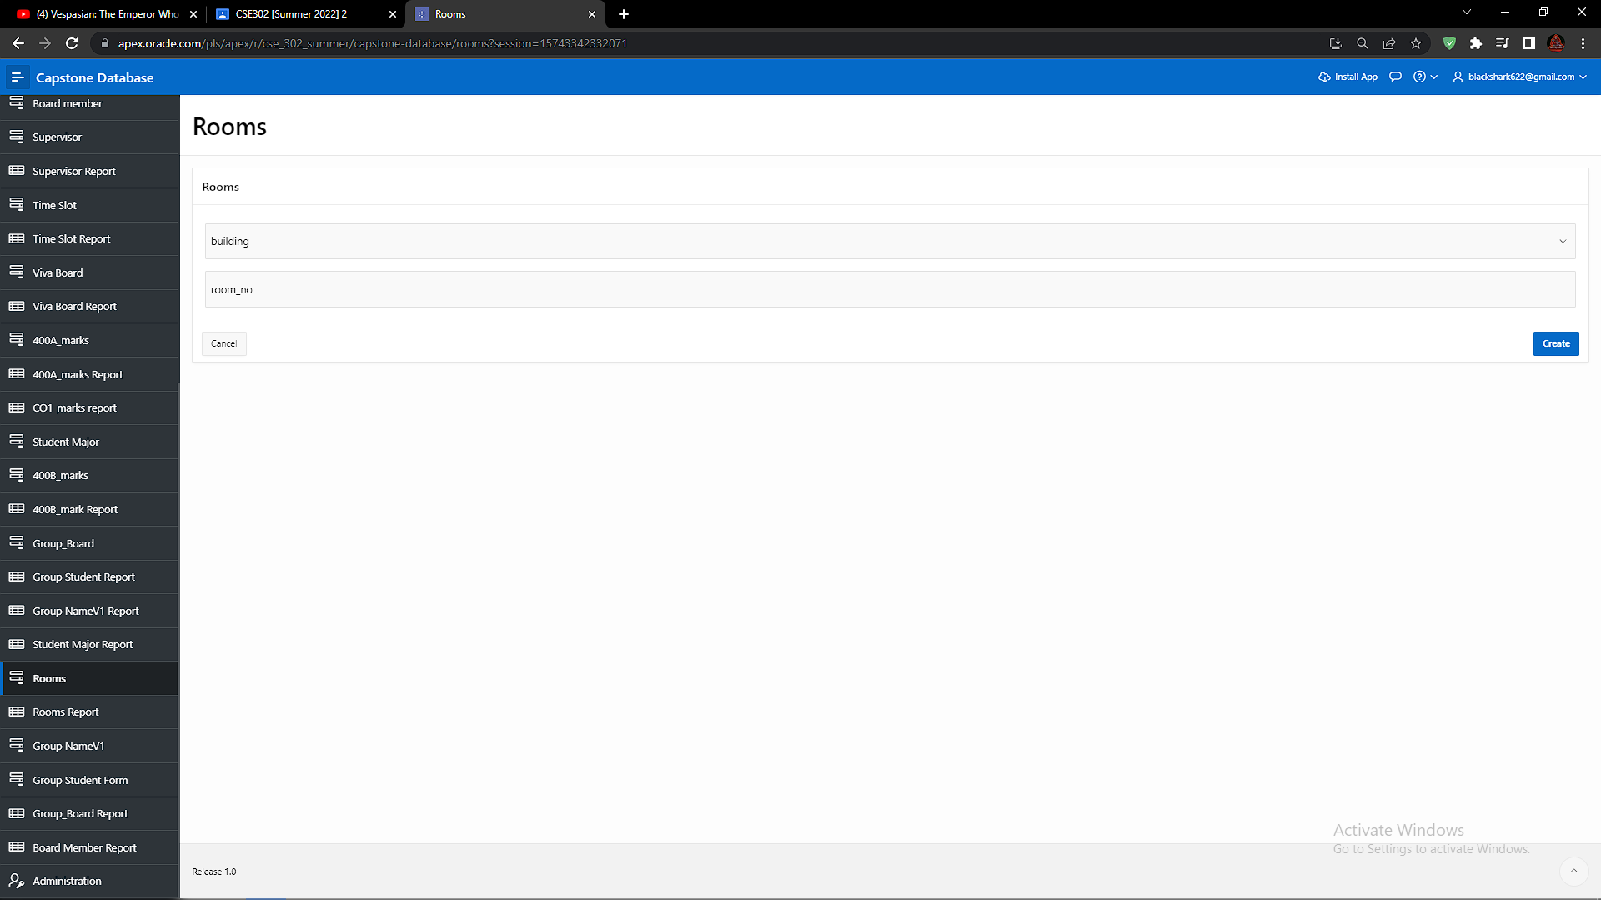

Fig-4.25

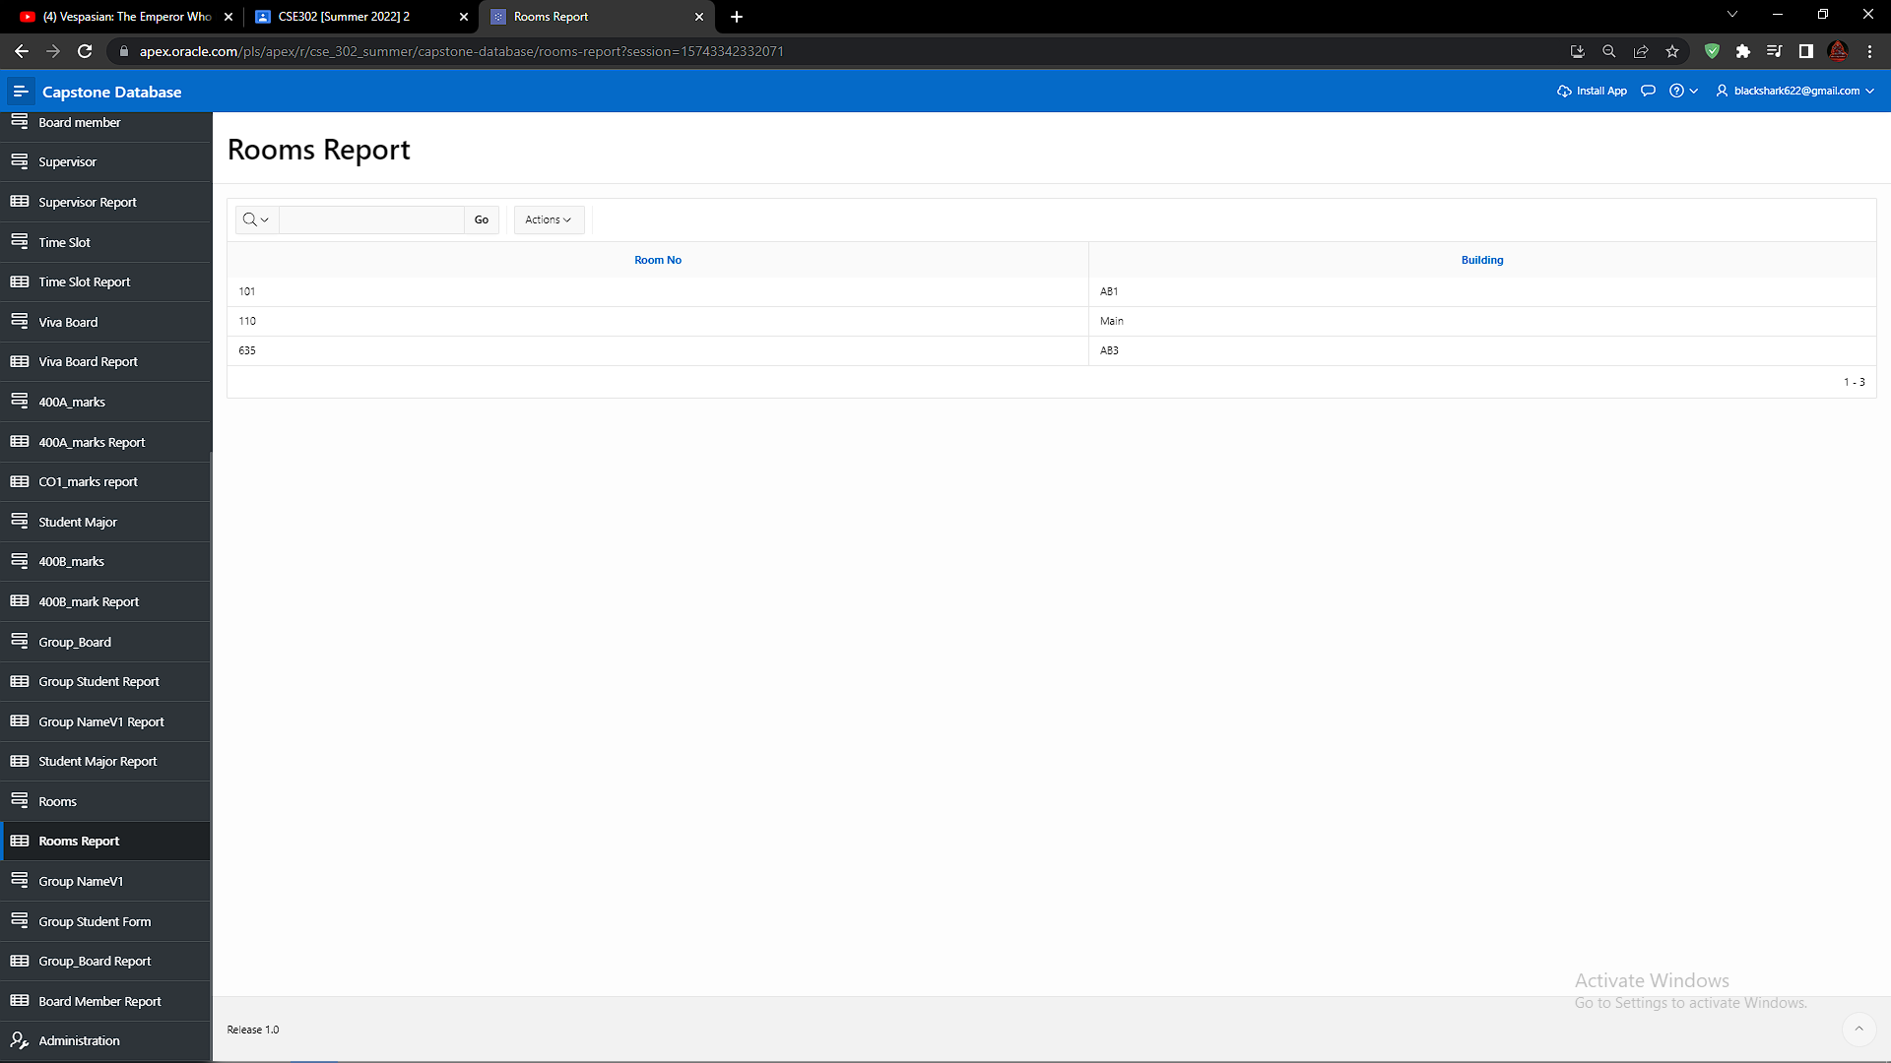

Fig-4.26

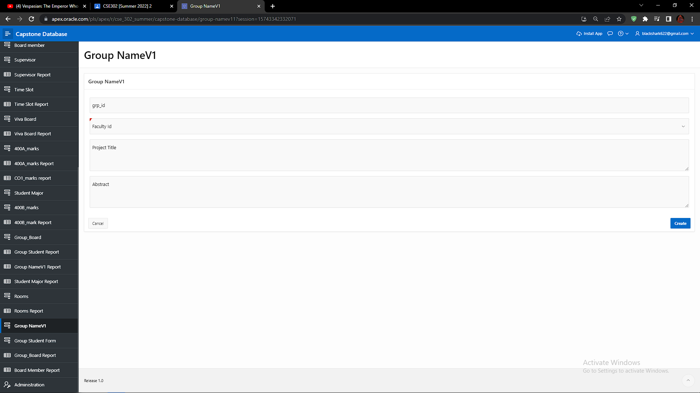

Fig-4.27

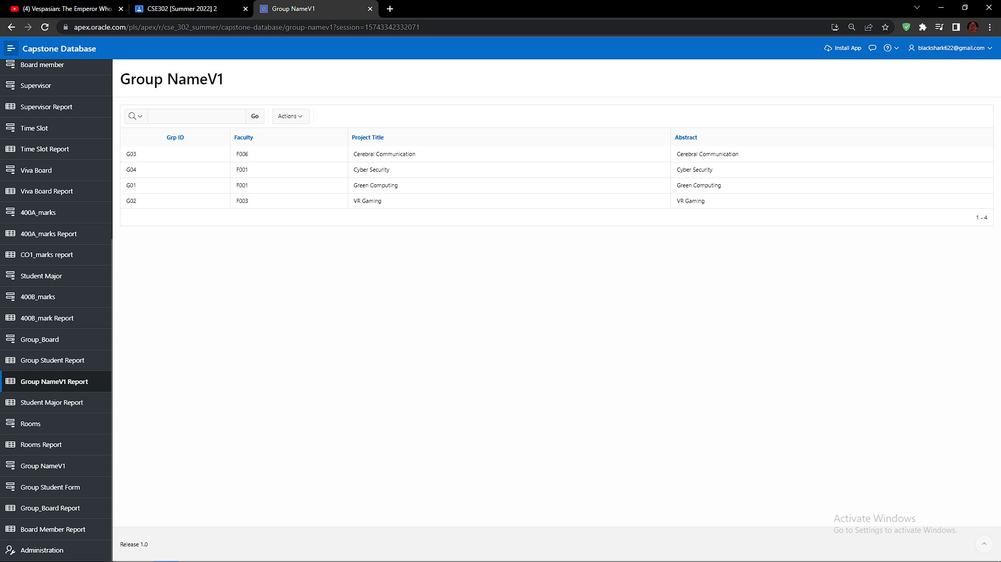

Fig- 4.28

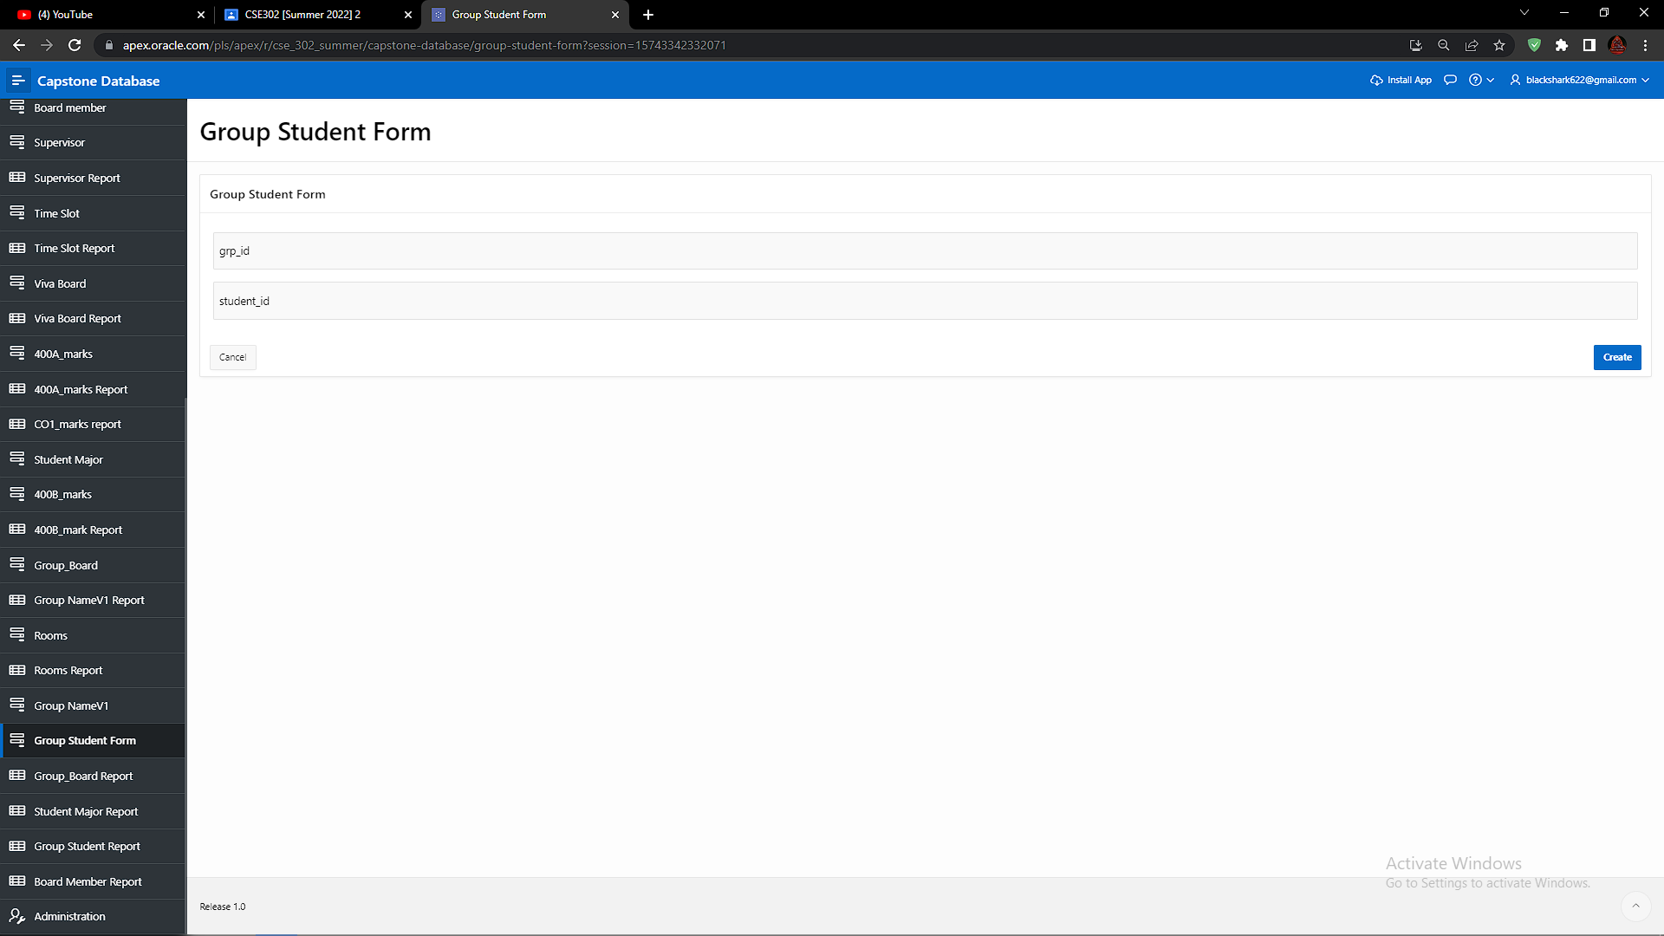

Fig-4.29

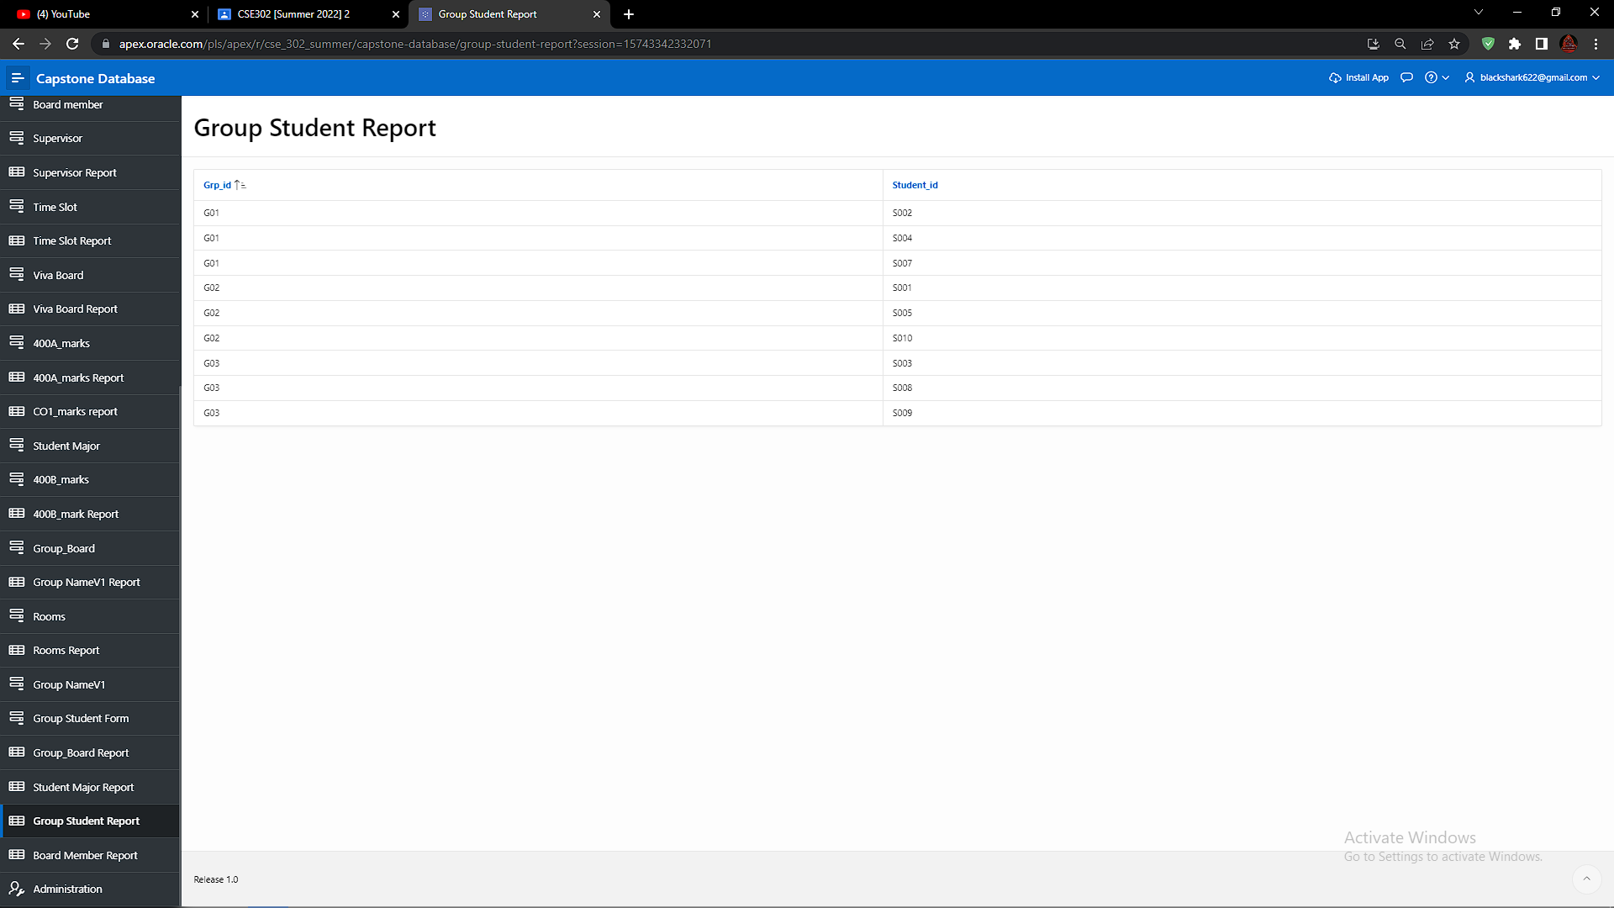

Fig-4.30

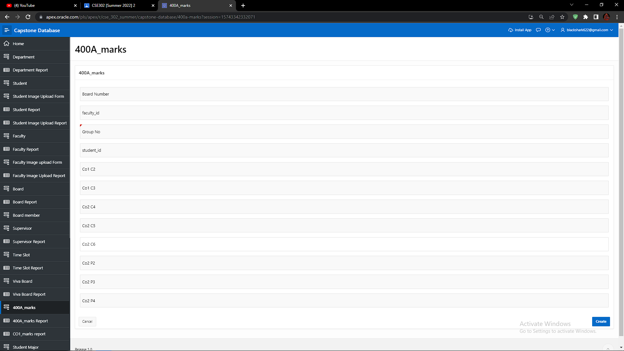

Fig-4.31

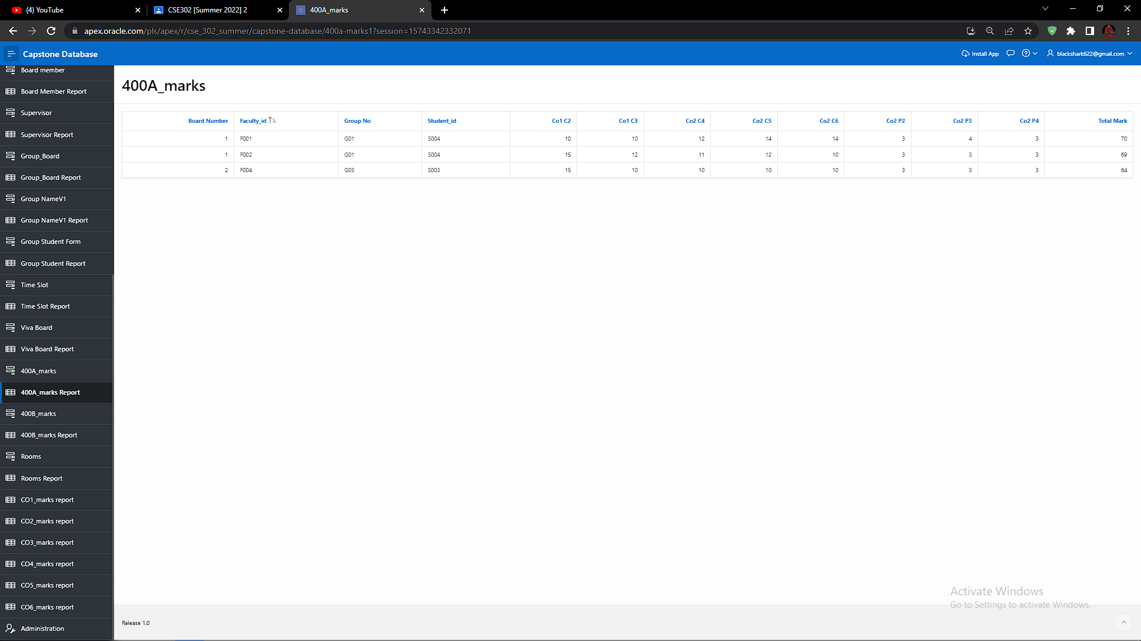

Fig- 4.32

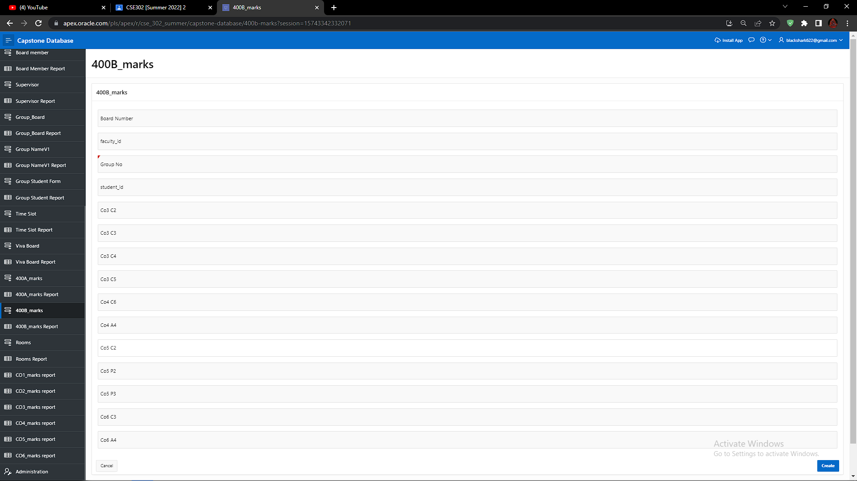

Fig- 4.33

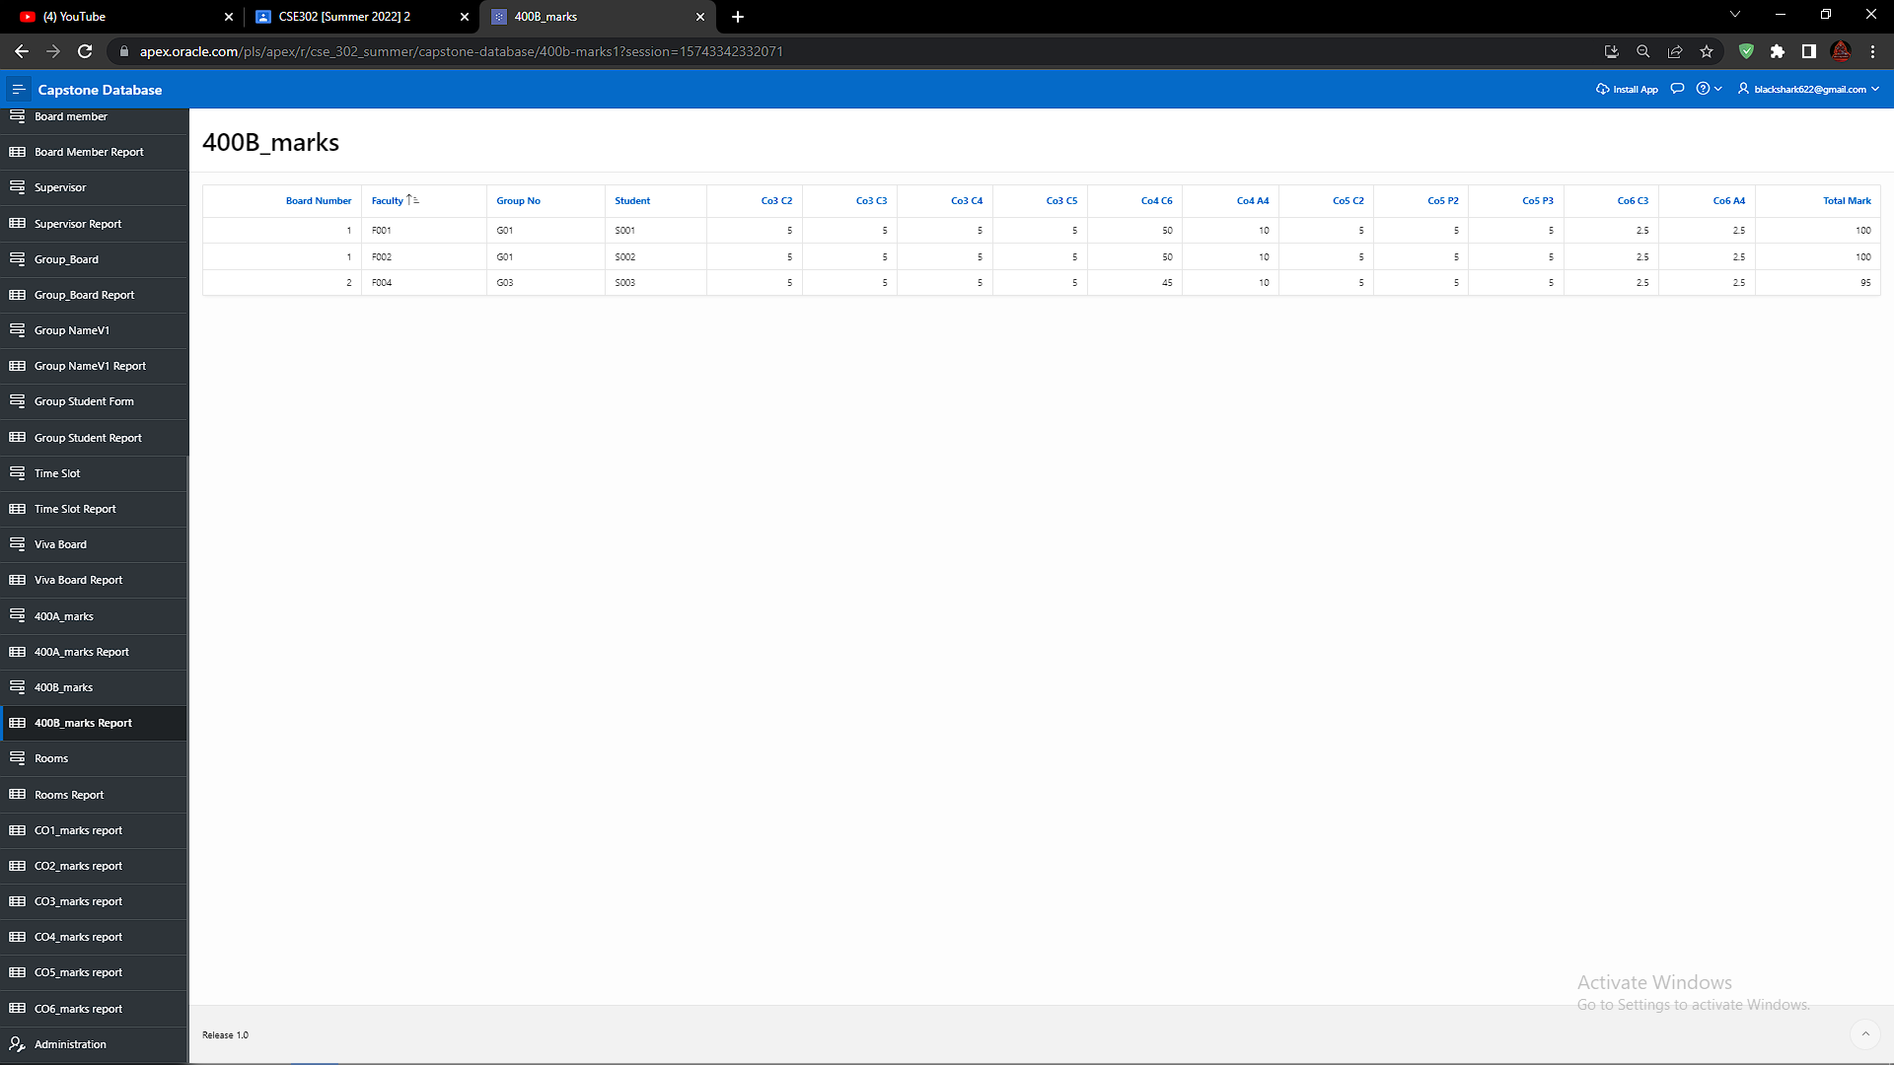

Fig- 4.34

# Master-Detail Form

|  |  |  |
| --- | --- | --- |
| Page Number and Name | Master Table (Parent) | Detail Table (Child) |
| Student 400A number | Student Major | 400A_mark by Faculty |
| Mark by Faculty (400A) | Faculty | 400A mark by Faculty, 400B_mark by Faculty |
|  |  |  |
|  |  |  |
|  |  |  |
|  |  |  |
|  |  |  |

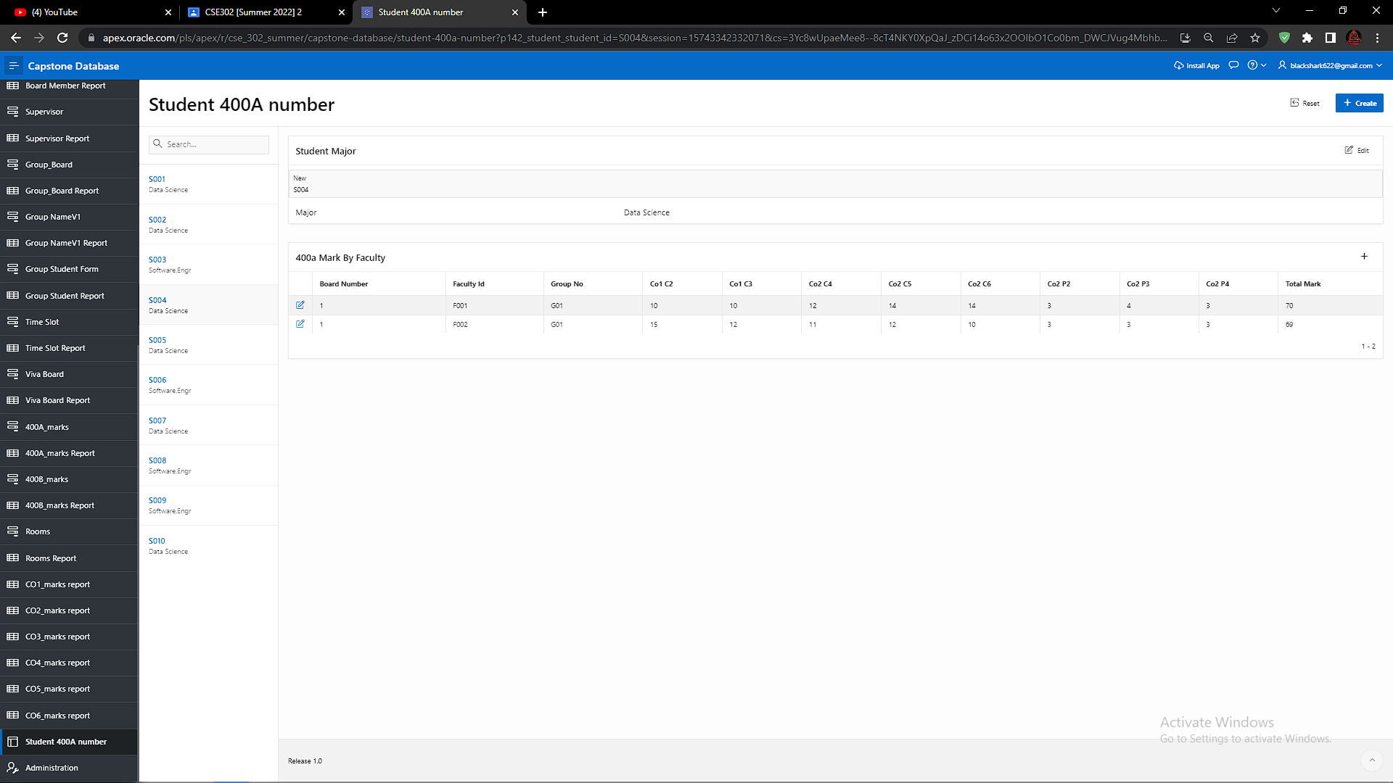

Fig- 5.1

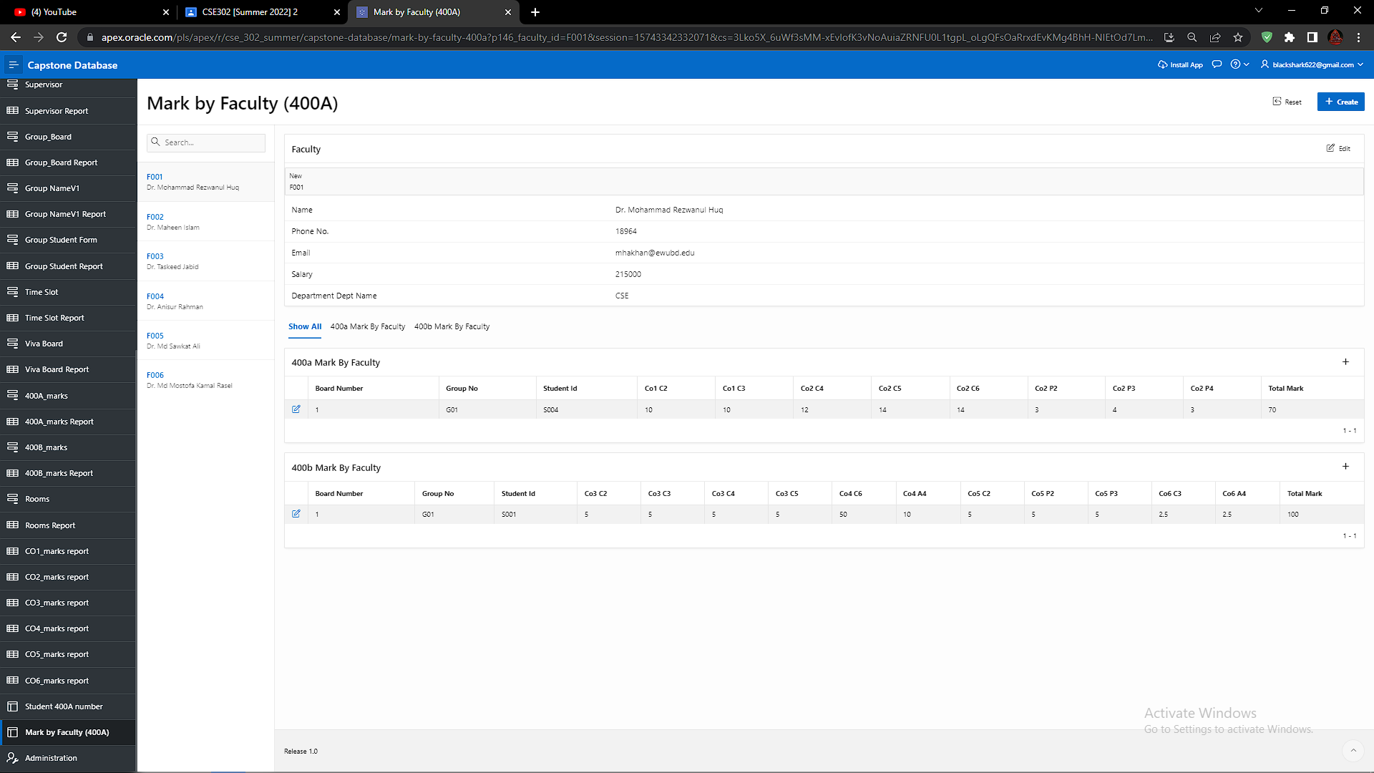

Fig- 5.2

# Reports based on Multi-Table and Aggregate Queries

|  |  |  |
| --- | --- | --- |
| Page Number and Name | Query Type | Report description |
| Dept_avg_salary | Aggregate | Find the average salary of CSE department |
| Building name starts with ‘A’ | LIKE | Find building names starts with letter A |
|  |  |  |
|  |  |  |
|  |  |  |
|  |  |  |
|  |  |  |

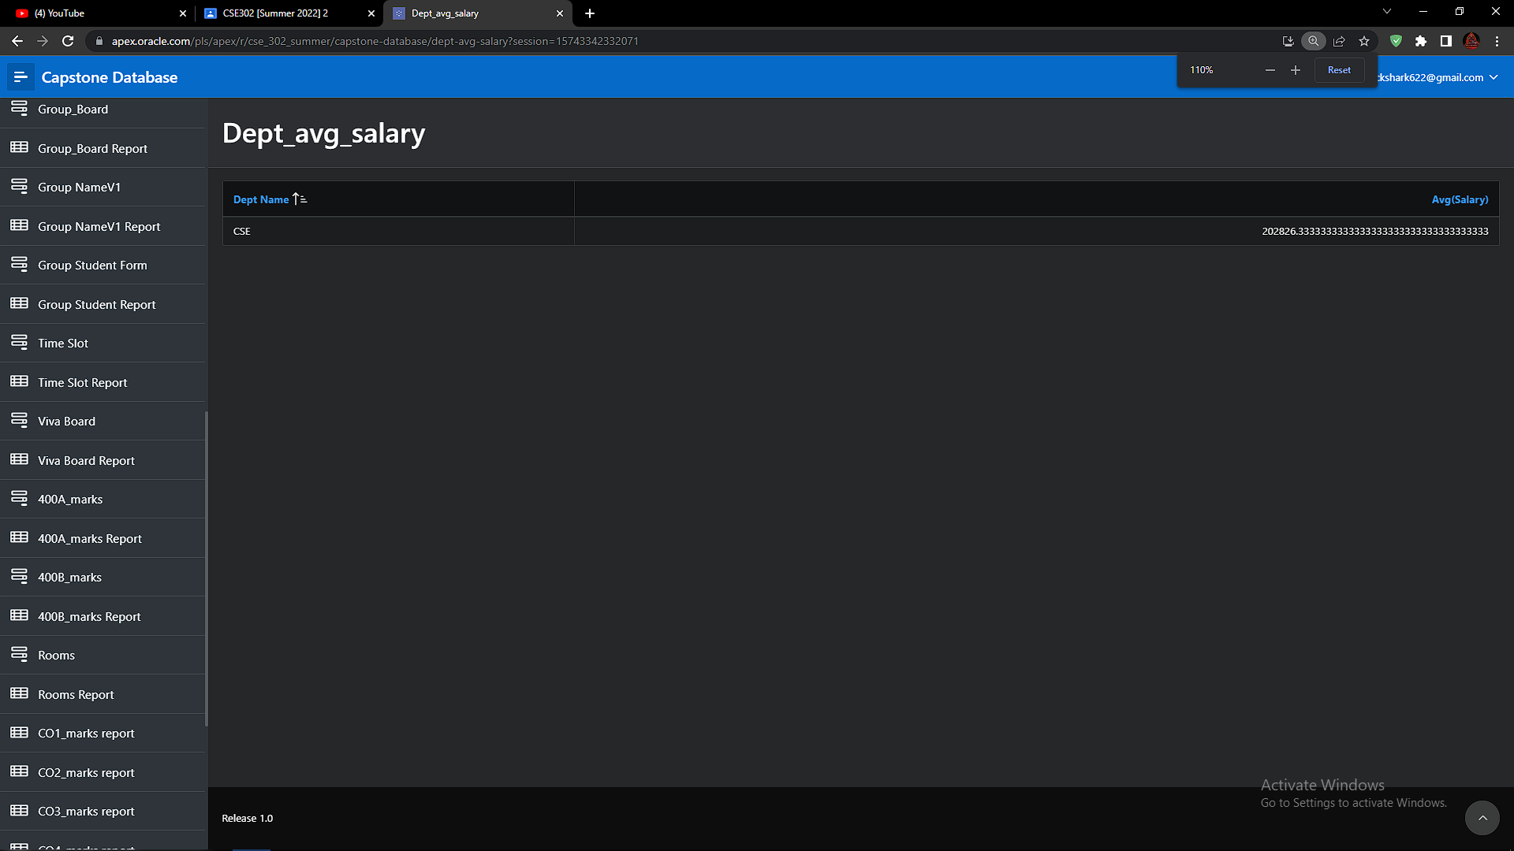

Fig-6.1

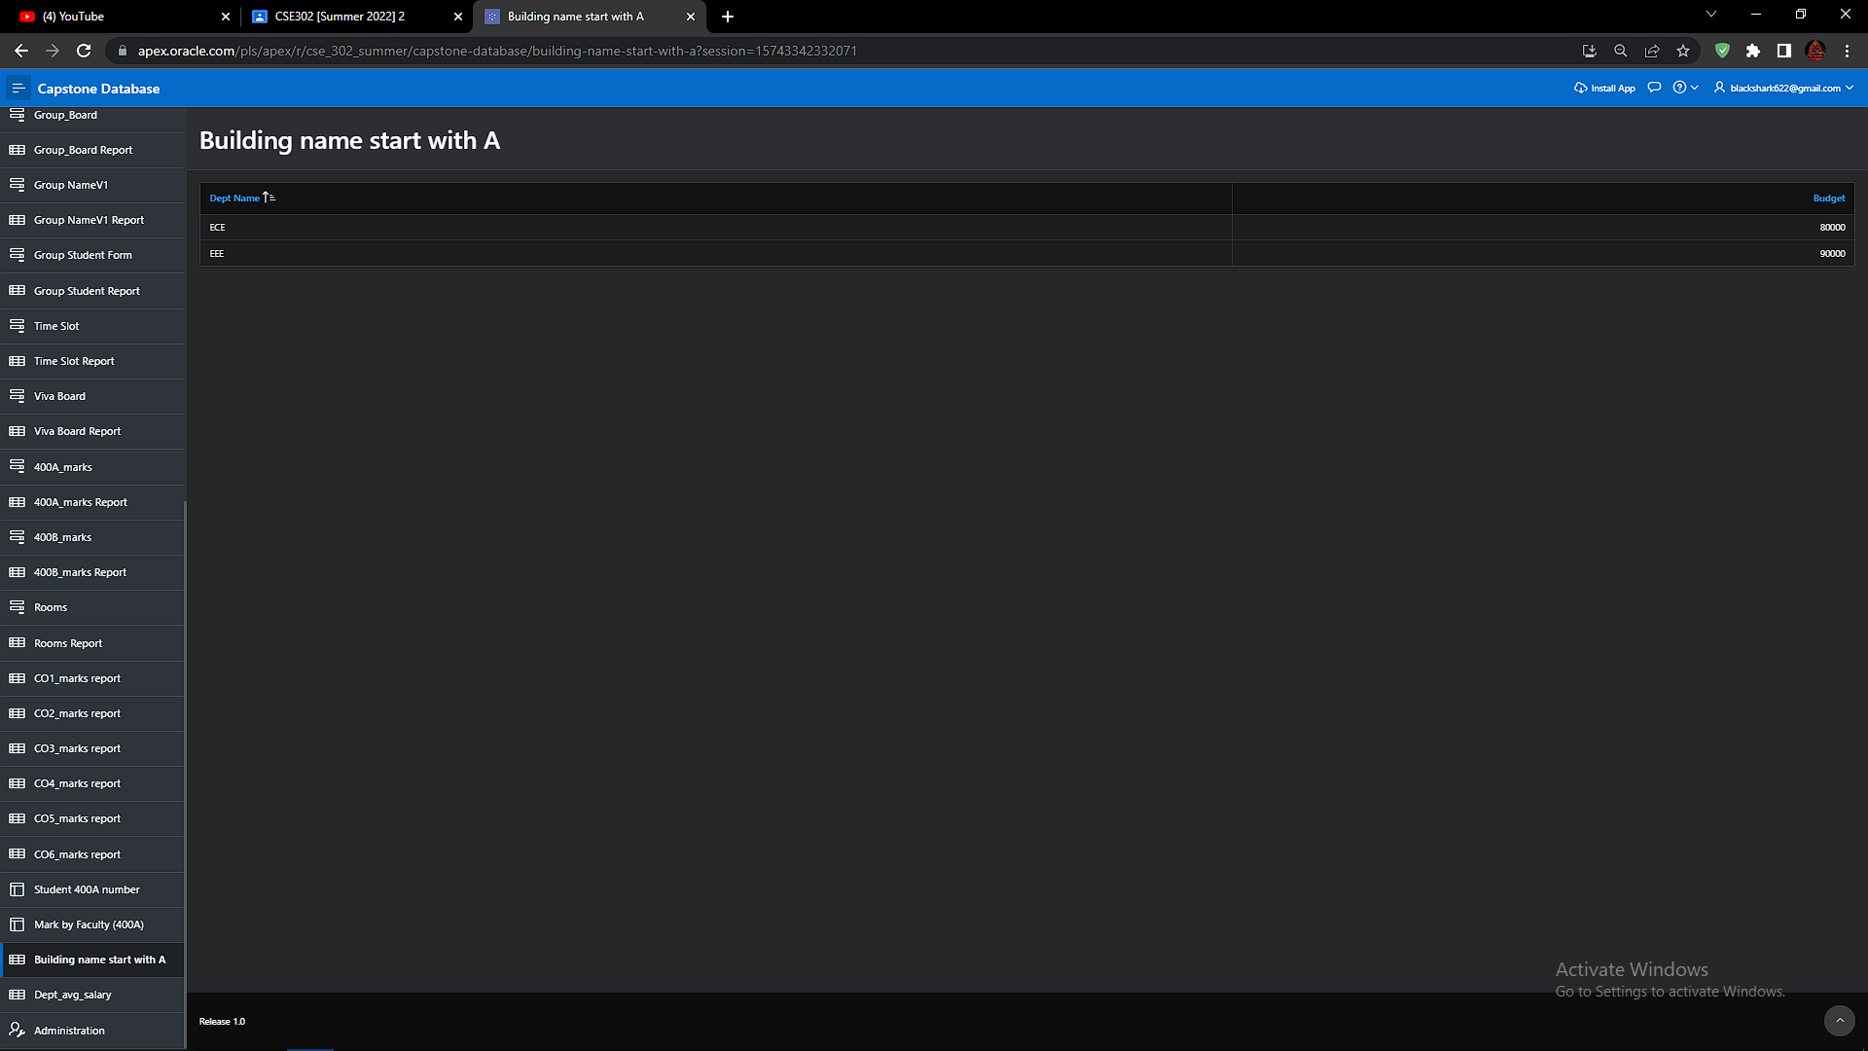

Fig-6.2

# Parameterized Reports

|  |  |  |
| --- | --- | --- |
| Page Number and Name | Given Input | Report description |
| Student | student_id, name, phone_no, email, tot_credit, dept_name | Student Table |
| Faculty | faculty_id, name, phone_no, email, salary, dept_name | Faculty table |
| Supervisor | (faculty_id) P/F | Supervisor |
|  |  |  |
|  |  |  |
|  |  |  |

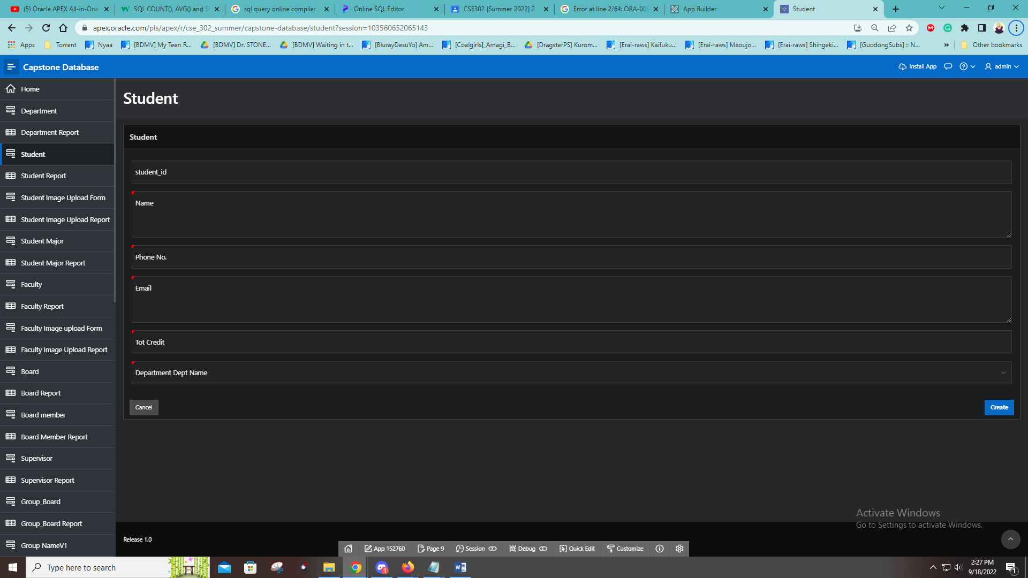

Fig-7.1

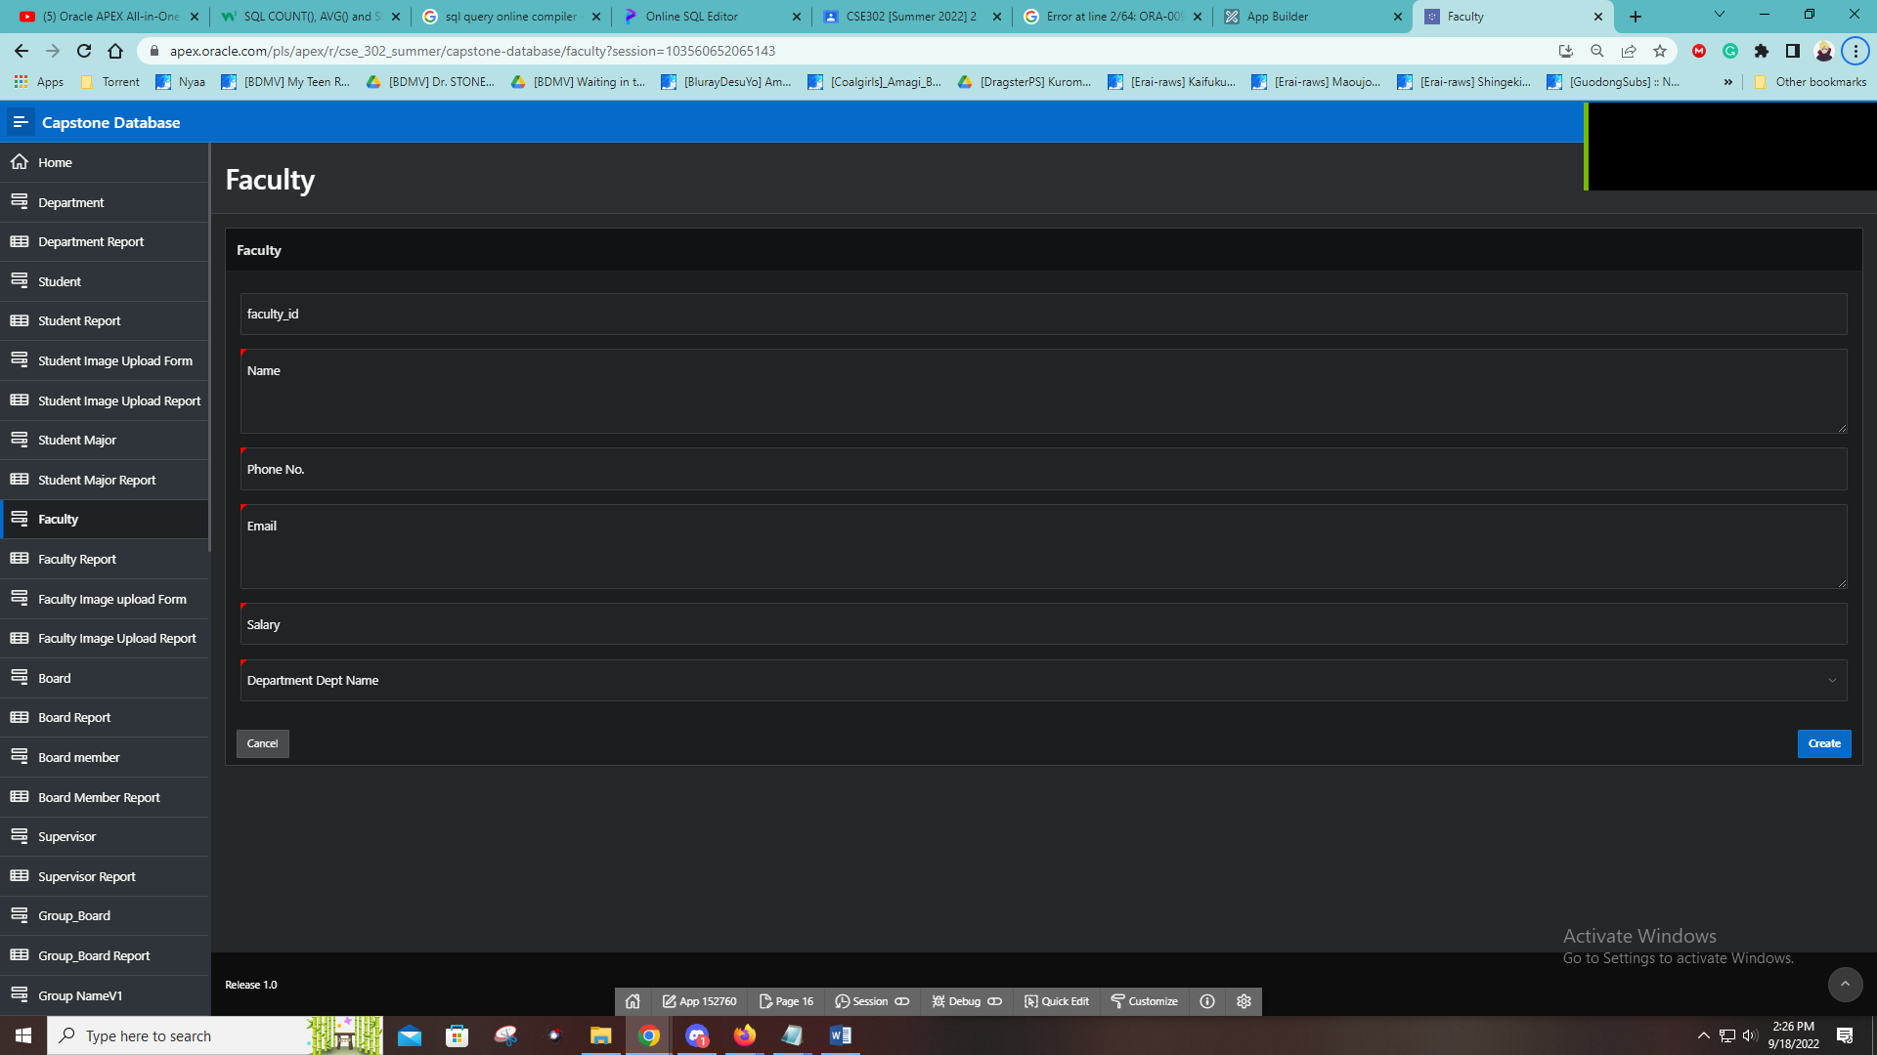

Fig 7.2

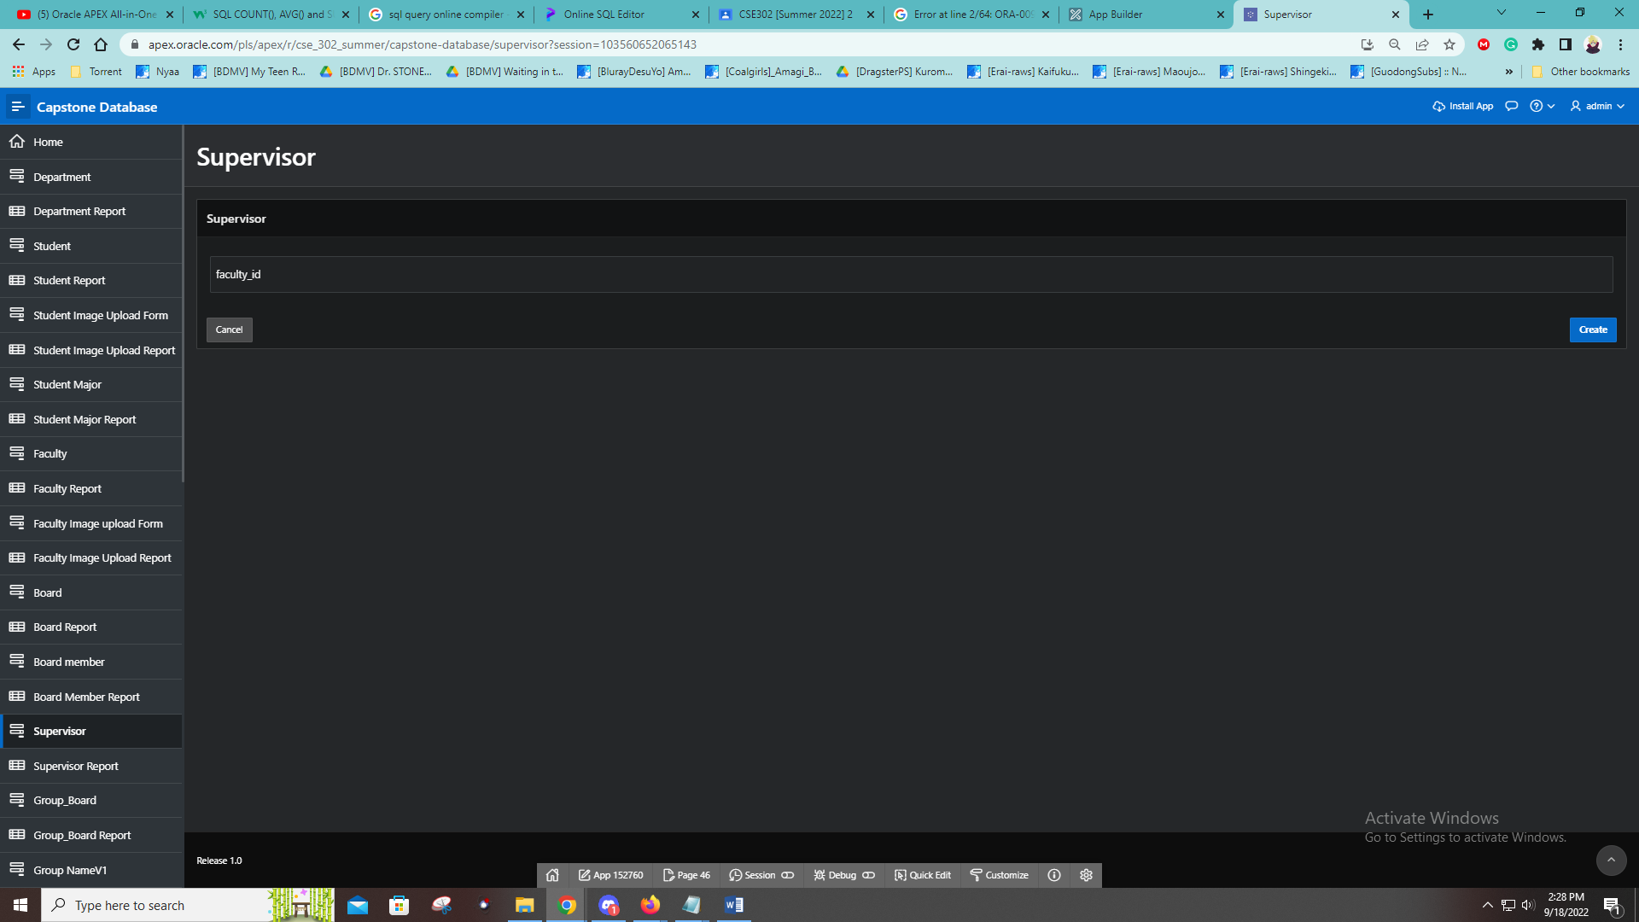

Fig-7.3

# Charts and Other Pages

|  |  |
| --- | --- |
| Page Number and Name | Chart description |
| Chart_table | Faculty_id vs Salary |
|  |  |
|  |  |
|  |  |
|  |  |
|  |  |

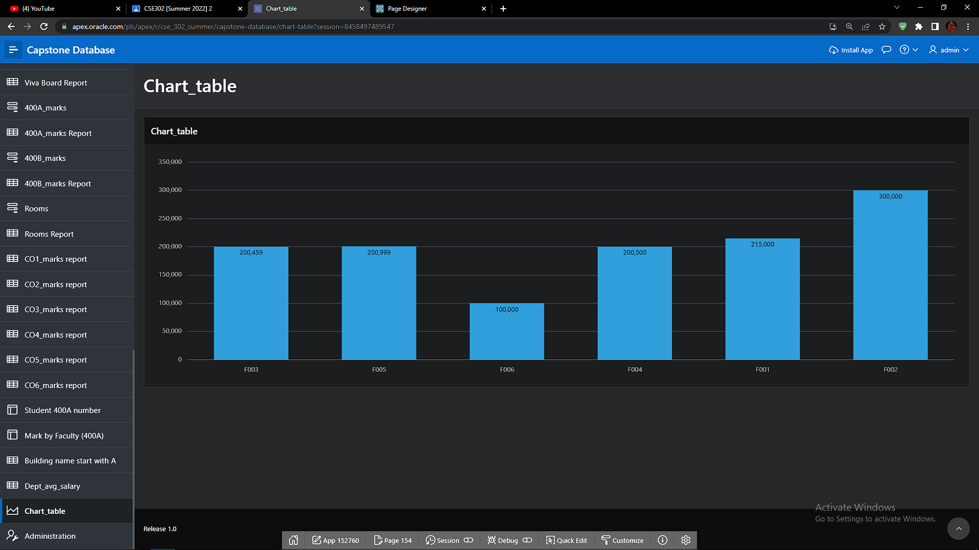

Fig-8.1

# Authorization and User Role Assignment

**User Role Assignment**

|  |  |  |
| --- | --- | --- |
| User name | Password | Role |
| admin | admin123 | Example: Administrator, Contributor |
| faculty | faculty123 | Contributor |
| student | student123 | Reader |
|  |  |  |

**Page-wise Authorization Information**

|  |  |
| --- | --- |
| Page number and name | Authorization Level |
| Example: P1. Home | Reader |
| Example: P10000: Administration | Administrator |
|  |  |
|  |  |
|  |  |
|  |  |

# Concluding Remarks

We wanted to give our best but we don’t know how much we gave in this project. We didn’t sleep for 2 days and we gave affords in this project. It was a bit struggling but we managed to come this far. But we enjoyed doing this project a lot.